**Reserve Name** **JOB** **NERR Water Quality Metadata**

**Months and year the documentation covers: 01/01/2024 to 12/31/2024**

**Latest Update**: 02/03/2025

Note: This is a provisional metadata document; it has not been authenticated as of its download date. Contents of this document are subject to change throughout the QAQC process and it should not be considered a final record of data documentation until that process is complete. Contact the CDMO <[cdmosupport@belle.baruch.sc.edu](mailto:cdmosupport@belle.baruch.sc.edu)> or Reserve with any additional questions.

**I. Data Set and Research Descriptors**

**1> Principal investigator<s> and contact persons**

**Jobos Bay National Estuarine Research Reserve**

**PO Box 159**

**Salinas, PR 00704-0159**

**Ph. 787-853-4617**

**Fx. 787-853-4618**

**Angel Dieppa, Research Coordinator**

**Ph. 787-853-4617**

**Email.** [**adieppa.jbnerr@gmail.com**](mailto:adieppa.jbnerr@gmail.com)**,** [**adieppa@drna.pr.gov**](mailto:adieppa@drna.pr.gov)

**Edlyn Jusino, SWMP Technician**

**Ph. 787-853-4617**

**Email.** [**edlynjusino.jbnerr@gmail.com**](mailto:edlynjusino.jbnerr@gmail.com) **,** [**edlyn.jusino@drna.pr.gov**](mailto:edlyn.jusino@drna.pr.gov)

**2> Entry verification**

Deployment data are uploaded from the YSI data logger to a Personal Computer by Edlyn Jusino. Files are exported from KOR-EXO (YSI Proprietary) program in a Microsoft Excel format by Edlyn Jusino and Angel Dieppa then excessive pre- and post-deployment data are removed from the file prior to upload with up to 2 hours of pre- and post-deployment data retained to assist in data management. Then it is converted to a comma-delimited file (*.cdf) and uploaded to the CDMO where it undergoes automated primary QAQC and becomes part of the CDMO’s online provisional database. During primary QAQC, data are flagged if they are missing or out of sensor range. The edited file is then returned to the Reserve where it is opened in Microsoft Excel and processed using the CDMO’s NERRQAQC Excel macro by Edlyn Jusino and Angel Dieppa. The macro inserts station codes, create metadata worksheets for flagged data and summary statistics, and graphs the data for review. It allows the user to apply QAQC flags and codes to the data, remove any overlapping deployment data, append files, and export the resulting data file for upload to the CDMO. Upload after secondary QAQC results in ingestion into the database as provisional plus data, recalculation of cDepth or cLevel parameters, and finally tertiary QAQC by the CDMO and assimilation into the CDMO’s authoritative online database. Where deployment overlap occurs between files, the data produced by the newly calibrated sonde is generally accepted as being the most accurate. The final yearly file and metadata was submitted by Edlyn Jusino and Angel Dieppa. For more information on QAQC flags and codes, see Sections 11 and 12.

**3> Research objectives –**

The principal objective is to record and track long-term changes and short term variability in water quality parameters that can be associated to changes in estuarine habitats. Through this, we support management decisions based on scientific data. A secondary objective is to promote the access and use of reliable baseline information by federal and local agencies, universities, researchers, educators and local communities to enhance the process by which they make decisions regarding their daily activities. This data is also invaluable in the identification and development of future monitoring and research activities.

A total of four data loggers <YSI EXO-2> are deployed in Jobos Bay. Two sondes are deployed in the inner lagoons of the Mar Negro Component and the other two in the Jobos Bay. The instruments are depth-fixed from a pole at a distance at about 0.5 meters from the bottom at each selected site. Data from stations 9, 10, 19 and 20 are being submitted to the Centralized Data Management Office as part of the System-Wide Monitoring Program. Measurements are taken at fifteen-minute intervals for approximately two-week periods. The sites are identified as representative of areas within the reserve and comparable to the sites that may be receiving impact from human activities from surroundings areas or may act as a habitat gradient in the Bay.

Station number nine <9>, subject to impacts from coastal processes <close to a power plant retentions pond>, collects water quality data in a site associated with runoff from littoral and basin mangrove areas. This sampling station is located in the most inland lagoon, closest to the Thermoelectric Power Plant <oil and natural gas>. It is subjected to runoff, which may include potential oil spill contamination from this industrial facility. Information compiled from historical environmental documents, indicate that station nine <9> was used as a disposal site for residues of the previously operating sugar mill operation, and therefore might have high organic input into the sediments.

Station number ten <10>, located in a mangrove lagoon area towards the southwestern section of Mar Negro is considered the reference or non-impacted site.

Station number <19> is located over a sea grass bed <*Thalassia testudinum*> in the inner western part of the bay just northeast of Cayo Colchones. This station is located near the thermal outfall and operating piers of the Aguirre Power Plant Complex, both activities may have significant effects on sea grass communities. This area is exposed to barge stranding, sediment re-suspension and oil spills.

Station number <20> is located on the eastern inner bay section of the Cayos Caribe cays. This station is just south of the mangrove islets associated with the Reserve's coral reefs. Water streams coming through the coral platform may help characterize water conditions of the main marine currents reaching Jobos Bay, as well as possible effects of industrial and chemical activities associated with Phillips Core, AES Coal Energy Plant and Pharmaceuticals located just east to this system.

**4> Research methods**

The National Estuarine Research Reserve Water Quality Monitoring Program began sampling at Station nine <9> on December 20, 1995 and Station ten <10> on February 1, 1996. Monitoring at station 19 began in April 2004 and at station 20 in June 2004. Long term water quality monitoring is being performed at these stations.

Before each YSI 6600 or EXO-2 data logger is deployed, calibration and maintenance is performed following the Standard Operation Procedures of the NERRS. Calibration standards are only required for pH, salinity, and turbidity, all other parameters are done as described in the manual. Buffer solutions for two-point calibration <pH 7 and pH 10> are purchased from a scientific supply company. Salinity is calibrated with a specific conductance standard 50 ms/cm and is purchased from YSI.

The two-point turbidity calibration is performed using a 0 NTU <DI water> and 124 FNU <for EXO-2> standard purchased from a scientific company. EXO-2 are equipped with dissolved oxygen optical sensors, both are allowed to sit at least 24 hours after proper calibration. Weather conditions and tide stage are recorded in the field observation log during deployment. Measurements of DO, pH, salinity, specific conductance, turbidity, and temperature are taken at the deployment time to check the accuracy and functionality of the instruments.

Each YSI data logger hangs inside a 6-inch diameter PVC pipe which is attached to a concrete filled PVC stable pole. Data loggers are at approximately 0.5 meter from the bottom of the selected site. Data is recorded every 15 minutes. The following measurements are recorded: date, time, temperature, specific conductance, salinity, dissolved oxygen saturation, dissolved oxygen concentration, depth, pH, and turbidity, all station have an optical chlorophyll-a sensor. Chl-a is an optional parameter non-required for SWMP program. Approximately, every two weeks the data loggers are retrieved, inspected, cleaned, data is downloaded into a personal computer and re-calibrated as noted previously. The data logger is then ready to be deployed again.

The data is processed through a standard quality control/quality assurance established for all 29 reserves within the system. It consists in submitting the raw data to the Centralized Data Management Office <CDMO> server where data undergoes through a macro to flag anomalies predetermine for each station. The data is sent back to the reserve to pass through a secondary QA/QC and finally resubmitted to CDMO for the final approval. Data may be available in different stages of the QA/QC process.

A Sutron Sat-Link2 transmitter was installed at the JOB20 station on 07/20/06 and a second station JOB09, transmits data to the NOAA GOES satellite, NESDIS ID # 3B0297EC and NESDIS ID # 3B0424AC respectively. The transmissions are scheduled hourly and contain four <4> data sets reflecting fifteen-minute data sampling intervals. Upon receipt by the CDMO, the data undergoes the same automated primary QAQC process detailed in Section 2 above. The “real-time” telemetry data become part of the provisional dataset until undergoing secondary and tertiary QAQC and assimilation in the CDMO’s authoritative online database. Provisional and authoritative data are available at [http://cdmo.baruch.sc.edu](http://cdmo.baruch.sc.edu/).

Station 20 and Station 9 telemetry was interrupted on 09/20/17 after Hurricane Maria destroyed the platform losing all the equipment. We are planning to reestablish communication in the near future.

**5> Site location and character –**

The Jobos Bay National Estuarine Research Reserve <JBNERR> is located on the southern coastal plain of the island of Puerto Rico, a reserve within the West Indies geographical area. JBNERR is composed of two major areas: <1> Mar Negro, located on the western margin of the Bay, and <2> Cayos Caribe <a chain of 17 tear-shaped islets located to the southeast> and Cayos Barca <a chain of 7 tear-shaped islets located to the southwest boundaries> both with a back-reef system. The Mar Negro area comprises the bulk of the Reserve, and consists of mangrove forests and a complex system of lagoons and channels interspersed with salt and mud flats. Coral reefs and sea grass beds, with small beach deposits and upland areas fringe Cayos Caribe and Cayos Barca mangrove islands. Few areas in the watershed drain directly to the bay. Rio Seco to the north-east of the bay is active only during heavy rain events during the wet season. A small creek, Quebrada Coqui, near JBNERR’s pier to the north of the bay, drains into an extensive mangrove fringe forest in a laminar flow. During heavy rain events, Station 09 received runoff water from the upland and finally, a diffuse flow of water reached the bay from the local aquifer.

Station 9 is an impacted site and is located on the northeastern section of the Mar Negro component. This sampling station is associated with mangrove lagoon areas and receives runoff from mudflats, the Thermoelectric Power Plant, and adjacent areas. The tidal range varies from 12 to 18 inches or 0.12 to 0.18 m near the monitoring station. The salinity in the vicinity of the monitoring station during this quarter varies from 22.5 ppt to 39.9 ppt. The average depth at station 09 are 0.30 and 0.95 meters. The bottom is covered by a thick layer of thin sediments with a high content of organic material. *Microcoleus sp.* <blue-green algae>, brown and green algae <*Caulerpa sp*.> are also present at this site, but a better assessment is needed. The station pole was located at 17°56'34.87"N and 66°14'18.64"W until 09/02/2010 12:00PM, then it was relocated to 17° 56' 35.0" N and 66° 14' 18.9" W approximately 65.0 meters from original position. The relocalization was due to sedimentation issues and the construction of a new telemetry station. Fresh water input to the station comes only from runoff and rain. This station has been subject of several studies indicating the presence of relatively high level of cooper and pesticides compared to other stations. Since 2015 an invasive seagrass, *Halophila stipulacea* was reported at Jobos Bay, it was after the pass of Hurricane Maria in September 21, 2017 that it was more evident and wide distributed. Although it is not present at Station 9, it is present in the channels toward the station and we expect it will colonize the area in the near future.

Station 10 is located in a mangrove lagoon not impacted directly by any upland or marine activities. It provides a reference for comparison of data obtained in other stations, especially to the station in Mar Negro lagoon. The tidal range varies from 12 to 18 inches or 0.12 to 0.18 m. The salinity at the vicinity of the monitoring station during this quarter varies from 25.4 ppt to 39.0 ppt. The average depth at station 10 is 0.23 and 0.79 meters. The bottom is covered with a layer of fine sediments with organic material, followed by a layer of calcareous material mainly from shells and oysters. At this site, we can find sea grass <*Thalassia testudinum*>, calcareous algae <*Halimeda* *sp.*>, green algae <*Caulerpa* *sp*.> and brown algae <*Dictyota* *sp*.> among others. The pole is located at 17° 56' 19.00 N, 66° 15' 27.85 W. Fresh water input to the station comes only from runoff and rain. There is not any direct source of fresh water. Since 2015 an invasive seagrass, *Halophila stipulacea* was reported at Jobos Bay, it was after the pass of Hurricane Maria in September 21, 2017 that it was more evident and wide distributed been observed in the perimeter of the station. See notes below regarding Sargassum arrivals.

Station 19 is located on the western inner section of the bay at a distance of 233 meters from Cayo Colchones Mangroves over sea grass beds <*Thallasia testudinum*>. Tidal ranges in this area vary from 12 to 18 inches or 0.12 to 0.18 m. The salinity at the vicinity of the monitoring station during this quarter varies from 17.7 ppt to 45.5 ppt. The average depth at this station is 0.35 and 1.09 meters. The YSI sonde is deployed at about 0.05 meter from the bottom. The bottom is of sandy composition. Sea grass, algae, echinoderms and other related organisms could be found in the area. The pole is located at 17° 56' 34.49"N, 66° 13' 43.77"W. There is no freshwater input to this area. Since 2015 an invasive seagrass, *Halophila stipulacea* was reported at Jobos Bay, it was after the pass of Hurricane Maria in September 21, 2017 that it was more evident and wide distributed been observed in the perimeter of the station.

Station 20 is located in the inner eastern section at about 190 meters of Cayos Caribe Mangrove islets and at about 688 meters from the coral reef barrier. This station is the closest to Mar Caribe. It has a sandy bottom, with calcareous and coral fragments, sea grass <*Thalassia testudinum*> communities, echinoderms and other associated organisms. Tidal ranges in this area vary from 12 to 18 inches or 0.12 to 0.18 m. The salinity at the vicinity of the monitoring station during this quarter varies from 30.00 ppt to 38.0 ppt. The average depth at this station is 0.17 and 0.77 meters. There is no surface freshwater input to this area. The pole is located at 17° 55' 49.14"N, 66° 12' 41.30"W. Since 2015 an invasive seagrass, *Halophila stipulacea* was reported at Jobos Bay, it was after the pass of Hurricane Maria in September 21, 2017 that it was more evident and wide distributed been observed in the perimeter of the station.

Data from stations 9, 10, 19, and 20 is being submitted to the CDMO. Eight sondes are permanently devoted to taking readings from these two sites, to assure continuous readings while sondes are taken out of the water for data upload and maintenance. This will avoid data gaps for the stations between sonde maintenance procedures. Due to errors in calibration, turbidity data in these files is considered inadequate. All monitoring is considered long term.

**Site location and character Tables:**

|  |  |
| --- | --- |
| **Site name** | **ST 09** |
| Latitude and longitude  *(Decimal degrees****or****degrees, minutes, seconds format)* | 17° 56' 35.0" N  66° 14' 18.9" W |
| Tidal range *(meters)* | 0.12 to 0.18 |
| Salinity range *(psu)* | 35.0 to 38.7 |
| Type and amount of freshwater input | This sampling station is associated with mangrove lagoon areas and receives runoff from mudflats, the Thermoelectric Power Plant, and adjacent areas. Fresh water input to the station comes only from runoff and rain. |
| Water depth (*meters, MLW*) | 0.24 |
| Sonde distance from bottom (*meters*) *Fixed distance sonde is deployed above the bottom* | 0.35 and 0.85 |
| Bottom habitat or type  *Soft sediment, grassbed, oyster bar, etc* | The bottom is covered by a thick layer of thin sediments with a high content of organic material. *Microcoleus sp.* <blue-green algae>, brown and green algae <*Caulerpa sp*.> are also present at this site, but a better assessment is needed. Since 2015 an invasive seagrass, *Halophila stipulacea* was reported at Jobos Bay, it was after the pass of Hurricane Maria in September 21, 2017 that it was more evident and wide distributed. Although it is not present at Station 9, it is present in the channels toward the station and we expect it will colonize the area in the near future. |
| Pollutants in area | Station 09 is an impacted site and is located on the northeastern section of the Mar Negro component. This sampling station is associated with mangrove lagoon areas and receives runoff from mudflats, the Thermoelectric Power Plant, and adjacent areas. This station has been subject of several studies indicating the presence of relatively high level of cooper and pesticides compared to other stations.  Station number nine <9>, subject to impacts from coastal processes <close to a power plant retentions pond>, collects water quality data in a site associated with runoff from littoral and basin mangrove areas. This sampling station is located in the most inland lagoon, closest to the Thermoelectric Power Plant <oil and natural gas>. It is subjected to runoff, which may include potential oil spill contamination from this industrial facility. Information compiled from historical environmental documents, indicate that station nine <9> was used as a disposal site for residues of the previously operating sugar mill operation, and therefore might have high organic input into the sediments.  A Baseline Assessment of the Ecological Resources of Jobos Bay, Puerto Rico founded this: ST 9 is named SWP 43, in ST 9 has found presence of this pollutants: Polycyclic Aromatic Hydrocarbons, Polychlorinated Biphenyls, Organochlorine insecticide ( Dichloro-diphenyltrichloroethane), and some and some major and trace elements. |
| Description of watershed  *(in reference to station)* | The Jobos Bay watershed is primarily comprised of the low-relief South Coastal Plain of Puerto Rico, but reaches elevations of greater than 700 m (2,297 ft) at its landward boundary. Many of Jobos Bay watershed’s physical characteristics are attributed to the presence of two of Puerto Rico’s Central Interior Mountain Ranges to the north, La Cordillera Central and La Sierra de Cayey. These mountains serve as a barrier to the moisture-laden northeast trade winds and give rise to a zone of low precipitation throughout the southern coast of Puerto Rico. The Jobos Bay watershed is located in the Subtropical Dry Forest Zone, the most arid ecological life zone in Puerto Rico.  The Central Aguirre subwatershed (SW3) has a total area of 16.5 km², one third of which is covered by intertidal lands. The northern reach of the basin begins just south of the convergence of Highways 52 and 53. It widens  as it extends southward towards Jobos Bay until a long serpentine coastline of over 20 km forms the southern boundary of the watershed. Most of the coastline is formed by the Mar Negro wetland complex, but it also extends beyond the Central Aguirre waterfront and shipping port. Similar to many subwatersheds in Jobos Bay, the Central Aguirre subwatershed has no defined stream channels and as a result discharges surface waters to Jobos Bay at several locations. A diversity of land cover types exist on the Central Aguirre subwatershed, including agriculture, industry, residential  development, and natural forested and wetland areas. The dominant feature in the watershed is Mar Negro’s mangrove forests and associated tidal waterways and mud flats. These wetlands are protected as part of the Jobos Bay National Estuarine Research Reserve. Mar Negro and another mangrove forest to its east comprise 32% of the subwatershed’s land cover. |

|  |  |
| --- | --- |
| **Site name** | **ST 10** |
| Latitude and longitude  *(Decimal degrees****or****degrees, minutes, seconds format)* | 17° 56' 19.00 N  66° 15' 27.85 W |
| Tidal range *(meters)* | 0.12 to 0.18 m |
| Salinity range *(psu)* | 33.8 to 37.6 |
| Type and amount of freshwater input | Fresh water input to the station comes only from runoff and rain. There is not any direct source of fresh water. |
| Water depth (*meters, MLW*) | 0.38 |
| Sonde distance from bottom (*meters*) *Fixed distance sonde is deployed above the bottom* | 0.25 and 0.77 meters |
| Bottom habitat or type  *Soft sediment, grassbed, oyster bar, etc* | The bottom is covered with a layer of fine sediments with organic material, followed by a layer of calcareous material mainly from shells and oysters. The bottom is covered with a layer of fine sediments with organic material, followed by a layer of calcareous material mainly from shells and oysters. At this site, we can find sea grass <*Thalassia testudinum*>, calcareous algae <*Halimeda* *sp.*>, green algae <*Caulerpa* *sp*.> and brown algae <*Dictyota* *sp*.> among others. Since 2015 an invasive seagrass, *Halophila stipulacea* was reported at Jobos Bay, it was after the pass of Hurricane Maria in September 21, 2017 that it was more evident and wide distributed been observed in the perimeter of the station. See notes below regarding Sargassum arrivals. |
| Pollutants in area | Characterizing Jobos Bay, Puerto Rico: A Watershed Modeling Analysis and Monitoring Plan has found: ST 10 located in a mangrove lagoon area towards the southwestern section of Mar Negro, is considered the reference or non-impacted site. This station is characterized by a low water exchange due to a restricted circulation pattern. This lagoon has an average depth of 2 m and the water regime is subject to high concentrations of tannin pigments associated with red mangroves. Benthic vegetation is scarce. This station is considered the less than impacted SWMP station in comparison with the other stations. But, this affirmation not significally 100% this station is not impacted.  In other study, A Baseline Assessment of the Ecological Resources of Jobos Bay, Puerto Rico founded this: ST 10 is named SWP44, in ST 10 has found presence of this pollutants: Polycyclic Aromatic Hydrocarbons, Polychlorinated Biphenyls, Organochlorine insecticide (Dichloro-diphenyltrichloroethane), and some and some major and trace elements. |
| Description of watershed  *(in reference to station)* | The Jobos Bay watershed is primarily comprised of the low-relief South Coastal Plain of Puerto Rico, but reaches elevations of greater than 700 m (2,297 ft) at its landward boundary. Many of Jobos Bay watershed’s physical characteristics are attributed to the presence of two of Puerto Rico’s Central Interior Mountain Ranges to the north, La Cordillera Central and La Sierra de Cayey. These mountains serve as a barrier to the moisture-laden northeast trade winds and give rise to a zone of low precipitation throughout the southern coast of Puerto Rico. The Jobos Bay watershed is located in the Subtropical Dry Forest Zone, the most arid ecological life zone in Puerto Rico.  The Central Aguirre subwatershed (SW3) has a total area of 16.5 km², one third of which is covered by intertidal lands. The northern reach of the basin begins just south of the convergence of Highways 52 and 53. It widens as it extends southward towards Jobos Bay until a long serpentine coastline of over 20 km forms the southern boundary of the watershed. Most of the coastline is formed by the Mar Negro wetland complex, but it also extends beyond the Central Aguirre waterfront and shipping port. Similar to many subwatersheds in Jobos Bay, the Central Aguirre subwatershed has no defined stream channels and as a result discharges surface waters to Jobos Bay at several locations. A diversity of land cover types exist on the Central Aguirre subwatershed, including agriculture, industry, residential development, and natural forested and wetland areas. The dominant feature in the watershed is Mar Negro’s mangrove forests and associated tidal waterways and mud flats. These wetlands are protected as part of the Jobos Bay National Estuarine Research Reserve. Mar Negro and another mangrove forest to its east comprise 32% of the subwatershed’s land cover. |

|  |  |
| --- | --- |
| **Site name** | **ST 19** |
| Latitude and longitude  *(Decimal degrees****or****degrees, minutes, seconds format)* | 17° 56' 34.49"N  66° 13' 43.77"W |
| Tidal range *(meters)* | 0.12 to 0.18 m |
| Salinity range *(psu)* | 31.4 to 37.8 |
| Type and amount of freshwater input | There is no freshwater input to this area. |
| Water depth (*meters, MLW*) | 0.44 |
| Sonde distance from bottom (*meters*) *Fixed distance sonde is deployed above the bottom* | 0.51 and 0.99 |
| Bottom habitat or type  *Soft sediment, grassbed, oyster bar, etc* | Station 19 is located on the western inner section of the bay at a distance of 233 meters from Cayo Colchones Mangroves over sea grass beds <*Thallasia testudinum*>. The bottom is of sandy composition. Sea grass, algae, echinoderms and other related organisms could be found in the area. Since 2015 an invasive seagrass, *Halophila stipulacea* was reported at Jobos Bay, it was after the pass of Hurricane Maria in September 21, 2017 that it was more evident and wide distributed been observed in the perimeter of the station. |
| Pollutants in area | This station is close to the power plant navigation channel used by barges to bring oil and gas into the power plant pier. This area is exposed to barge strandings and sediment re-suspension. Potential Oil spills are always a threat.  A Baseline Assessment of the Ecological Resources of Jobos Bay, Puerto Rico founded this: ST 19 is named CNT16, in ST 19 has found presence of this pollutants: Polycyclic Aromatic Hydrocarbons, Polychlorinated Biphenyls, Organochlorine insecticide (Dichloro-diphenyltrichloroethane), and some and some major and trace elements. |
| Description of watershed  *(in reference to station)* | The Jobos Bay watershed is primarily comprised of the low-relief South Coastal Plain of Puerto Rico, but reaches elevations of greater than 700 m (2,297 ft) at its landward boundary. Many of Jobos Bay watershed’s physical characteristics are attributed to the presence of two of Puerto Rico’s Central Interior Mountain Ranges to the north, La Cordillera Central and La Sierra de Cayey. These mountains serve as a barrier to the moisture-laden northeast trade winds and give rise to a zone of low precipitation throughout the southern coast of Puerto Rico. The Jobos Bay watershed is located in the Subtropical Dry Forest Zone, the most arid ecological life zone in Puerto Rico. |

|  |  |
| --- | --- |
| Site name | ST 20 |
| Latitude and longitude  *(Decimal degrees****or****degrees, minutes, seconds format)* | 17° 55' 49.14"N  66° 12' 41.30"W |
| Tidal range *(meters)* | 0.12 to 0.18 m |
| Salinity range *(psu)* | 31.1 to 38.0 |
| Type and amount of freshwater input | There is no surface freshwater input to this area. |
| Water depth (*meters, MLW*) | 0.23 |
| Sonde distance from bottom (*meters*) *Fixed distance sonde is deployed above the bottom* | 0.25 and 0.73 meters |
| Bottom habitat or type  *Soft sediment, grassbed, oyster bar, etc* | Station 20 is located in the inner eastern section at about 190 meters of Cayos Caribe Mangrove islets and at about 688 meters from the coral reef barrier. This station is the closest to Mar Caribe. It has a sandy bottom, with calcareous and coral fragments, sea grass <*Thalassia testudinum*> communities, echinoderms and other associated organisms. Since 2015 an invasive seagrass, *Halophila stipulacea* was reported at Jobos Bay, it was after the pass of Hurricane Maria in September 21, 2017 that it was more evident and wide distributed been observed in the perimeter of the station. |
| Pollutants in area | ST 20 it is located adjacent to the Cayos Caribe reef system. Water streams coming from the reef platform may mean that this station is representative of water conditions behind the coral reef. These waters are part of the main marine current coming from the eastern side of Jobos Bay that runs along the coast, coming into contact with potential sources such as agricultural fields, a coal power plant, a Phillips Core oil refinery (closed in 2005) and other industries.  A Baseline Assessment of the Ecological Resources of Jobos Bay, Puerto Rico founded this: ST 20 is named SWP41, in ST 20 has found presence of this pollutants: Polycyclic Aromatic Hydrocarbons, Polychlorinated Biphenyls, Organochlorine insecticide (Dichloro-diphenyltrichloroethane), and some and some major and trace elements. |
| Description of watershed  *(in reference to station)* | The Jobos Bay watershed is primarily comprised of the low-relief South Coastal Plain of Puerto Rico, but reaches elevations of greater than 700 m (2,297 ft) at its landward boundary. Many of Jobos Bay watershed’s physical characteristics are attributed to the presence of two of Puerto Rico’s Central Interior Mountain Ranges to the north, La Cordillera Central and La Sierra de Cayey. These mountains serve as a barrier to the moisture-laden northeast trade winds and give rise to a zone of low precipitation throughout the southern coast of Puerto Rico. The Jobos Bay watershed is located in the Subtropical Dry Forest Zone, the most arid ecological life zone in Puerto Rico.  SW9 is the most near place of sampling near to St 20. The Punta Pozuelo subwatershed does not support any agricultural, commercial or industrial land uses. Furthermore, most of the drainage area is covered by natural vegetation. As a result, the small subwatershed contributes only negligible amounts of predicted pollutant loads to Jobos Bay and the Caribbean Sea. The Punta Pozuelo subwatershed’s 3.4 km² form a peninsula that separates the protected waters of  inner Jobos Bay from the Caribbean Sea. Punta Pozuelo connects to the Puerto Rican mainland by a 300 m wide shared border with the Barrio Jobos subwatershed. The subwatershed is the only basin in the study area that does not discharge its entire runoff into Jobos Bay. The peninsula lacks any substantial relief and is too narrow to allow surface runoff to aggregate and form major stream channels. Instead, surface waters generated by precipitation events discharge to the nearest shoreline by overland sheet flow. As a result, surface flow from the Punta Pozuelo subwatershed will be distributed between Jobos Bay  and the Caribbean Sea. During rain events, a sediment plume drains west from the shallow coastal lagoons of Punta Pozuelo into Jobos Bay. |

**References:**

Characterizing Jobos Bay, Puerto Rico: A Watershed Modeling Analysis and Monitoring Plan

<https://repository.library.noaa.gov/view/noaa/496/noaa_496_DS1.pdf>

Zitello, A.G., D.R. Whitall, A. Dieppa, J.D. Christensen, M.E. Monaco and S.O. Rohmann. 2008. Characterizing Jobos Bay, Puerto Rico: A Watershed Modeling Analysis and Monitoring Plan. NOAA Technical Memorandum NOS NCCOS 76. 81 pp.

A Baseline Assessment of the Ecological Resources of Jobos Bay, Puerto Rico

[https://repository.library.noaa.gov/view/noaa/669/noaa_669_DS1.pdf](https://gcc02.safelinks.protection.outlook.com/?url=https%3A%2F%2Frepository.library.noaa.gov%2Fview%2Fnoaa%2F669%2Fnoaa_669_DS1.pdf&data=05%7C02%7Cedlyn.jusino%40drna.pr.gov%7Ce5e0921912f14ecd695d08dc97a44ddd%7Cb41b5a85a9c4415eb95ab97d761f6778%7C0%7C0%7C638551979166438984%7CUnknown%7CTWFpbGZsb3d8eyJWIjoiMC4wLjAwMDAiLCJQIjoiV2luMzIiLCJBTiI6Ik1haWwiLCJXVCI6Mn0%3D%7C0%7C%7C%7C&sdata=lvCHTJFUiqAMa5nuoUxpTA7CnKw5T%2FsLBWQYUscPDj0%3D&reserved=0)

Whitall, D.R., B.M. Costa, L.J. Bauer, A. Dieppa, and S.D. Hile (eds.). 2011. A Baseline Assessment of the Ecological Resources of Jobos Bay, Puerto Rico. NOAA Technical Memorandum NOS NCCOS 133. Silver Spring, MD. 188 pp.

The Mean low water “MLW” and Mean High water “MHW”, is calculated based on 21 years 6 months of historical data of Depth (m) of JOB NERR, SWMP Stations. For Mean low water was used a minimum Depth tides values (m) and for Mean high water was used a maximum Depth tides values (m) of SWMP Stations. For calculated this values JOB NERR, used this references: [https://tidesandcurrents.noaa.gov/datum_options.html - MLW](https://tidesandcurrents.noaa.gov/datum_options.html#MLW), <https://tidesandcurrents.noaa.gov/datum-updates/ntde/>. “National Tidal Datum Epoch “NTDE” specify is necessary a 19-year time period established by National Ocean Service for collecting observations on water levels and calculating tidal values”.

**ST 09:**

|  |  |  |
| --- | --- | --- |
| **MLW - MHW ST 09** | | |
| **DEPTH (m)** | | |
| **YEARS** | **MIN**  **Tides Values (MLW)** | **MAX**  **Tides Values (MHW)** |
| 2003 | 0.23 | 0.88 |
| 2004 | 0.12 | 0.82 |
| 2005 | 0.16 | 0.96 |
| 2006 | 0.04 | 0.75 |
| 2007 | 0.14 | 0.77 |
| 2008 | 0.21 | 0.87 |
| 2009 | 0.24 | 0.84 |
| 2010 | 0.23 | 0.90 |
| 2011 | 0.02 | 0.73 |
| 2012 | 0.14 | 0.79 |
| 2013 | 0.25 | 0.79 |
| 2014 | 0.30 | 0.84 |
| 2015 | 0.31 | 0.84 |
| 2016 | 0.29 | 0.84 |
| 2017 | 0.28 | 1.29 |
| 2018 | 0.39 | 0.98 |
| 2019 | 0.53 | 1.09 |
| 2020 | 0.35 | 0.88 |
| 2021 | 0.29 | 0.97 |
| 2022 | 0.37 | 1.16 |
| 2023 | 0.31 | 0.91 |
| 2024  \**(Until 06-17-2024)\** | 0.02 | 0.85 |
| **AVERAGE** | **0.24** | **0.90** |
| **STD DEV** | **0.13** | **0.14** |

**ST 10:**

|  |  |  |
| --- | --- | --- |
| **MLW - MHW ST 10** | | |
| **DEPTH (m)** | | |
| **YEARS** | **MIN**  **Tides Values (MLW)** | **MAX**  **Tides Values (MHW)** |
| 2003 | 0.57 | 1.13 |
| 2004 | 0.46 | 1.12 |
| 2005 | 0.53 | 1.12 |
| 2006 | 0.49 | 1.18 |
| 2007 | 0.37 | 1.05 |
| 2008 | 0.29 | 0.92 |
| 2009 | 0.27 | 0.97 |
| 2010 | 0.33 | 0.94 |
| 2011 | 0.36 | 0.94 |
| 2012 | 0.04 | 1.03 |
| 2013 | 0.53 | 1.12 |
| 2014 | 0.62 | 1.30 |
| 2015 | 0.38 | 1.24 |
| 2016 | 0.38 | 0.89 |
| 2017 | 0.37 | 1.12 |
| 2018 | 0.38 | 0.97 |
| 2019 | 0.44 | 1.06 |
| 2020 | 0.33 | 0.87 |
| 2021 | 0.26 | 0.94 |
| 2022 | 0.36 | 0.86 |
| 2023 | 0.29 | 0.84 |
| 2024  \**(Until 06-17-2024)\** | 0.25 | 0.77 |
| **AVERAGE** | **0.38** | **1.02** |
| **STD DEV** | **0.13** | **0.14** |

**ST 19:**

|  |  |  |
| --- | --- | --- |
| **MLW - MHW ST 19** | | |
| **DEPTH (m)** | | |
| **YEARS** | **MIN**  **Tides Values (MLW)** | **MAX**  **Tides Values (MHW)** |
| 2003 | 0.62 | 1.24 |
| 2004 | 0.58 | 1.46 |
| 2005 | 0.74 | 1.42 |
| 2006 | 0.70 | 1.40 |
| 2007 | 0.57 | 1.29 |
| 2008 | 0.52 | 1.15 |
| 2009 | 0.53 | 1.03 |
| 2010 | 0.37 | 0.93 |
| 2011 | 0.01 | 1.66 |
| 2012 | 0.03 | 1.09 |
| 2013 | 0.10 | 1.00 |
| 2014 | 0.44 | 0.95 |
| 2015 | 0.41 | 0.96 |
| 2016 | 0.41 | 1.03 |
| 2017 | 0.52 | 1.31 |
| 2018 | 0.55 | 1.06 |
| 2019 | 0.53 | 1.09 |
| 2020 | 0.54 | 1.11 |
| 2021 | 0.45 | 1.13 |
| 2022 | 0.31 | 1.10 |
| 2023 | 0.21 | 0.99 |
| 2024  \**(Until 06-17-2024)\** | 0.50 | 0.99 |
| **AVERAGE** | **0.44** | **1.15** |
| **STD DEV** | **0.20** | **0.19** |

**ST 20:**

|  |  |  |
| --- | --- | --- |
| **MLW - MHW ST 20** | | |
| **DEPTH (m)** | | |
| **YEARS** | **MIN**  **Tides Values (MLW)** | **MAX**  **Tides Values (MHW)** |
| 2003 | 0.30 | 0.93 |
| 2004 | 0.28 | 0.89 |
| 2005 | 0.33 | 0.97 |
| 2006 | 0.04 | 0.75 |
| 2007 | 0.27 | 1.01 |
| 2008 | 0.02 | 0.95 |
| 2009 | 0.25 | 0.91 |
| 2010 | 0.42 | 1.14 |
| 2011 | 0.01 | 1.48 |
| 2012 | 0.03 | 1.07 |
| 2013 | 0.02 | 1.05 |
| 2014 | 0.55 | 1.06 |
| 2015 | 0.50 | 1.01 |
| 2016 | 0.19 | 1.35 |
| 2017 | 0.03 | 1.35 |
| 2018 | 0.19 | 1.06 |
| 2019 | 0.27 | 0.79 |
| 2020 | 0.29 | 0.84 |
| 2021 | 0.23 | 0.86 |
| 2022 | 0.31 | 0.82 |
| 2023 | 0.26 | 0.78 |
| 2024  \**(Until 06-17-2024)\** | 0.24 | 0.73 |
| **AVERAGE** | **0.23** | **0.99** |
| **STD DEV** | **0.15** | **0.20** |

**6> Data collection period –** Include each YSI deployment and retrieval date and time <**first** and **last** readings in the water> for each monitoring site for the year. Do not include times of pre- and post-deployment or datasondes’ transport. Note when data collection began initially for your Reserve or sample sites.

Station nine <9> water quality monitoring began on December 20, 1995.

Station ten <10> water quality monitoring began on February 1, 1996.

Station nineteen <19> water quality monitoring began on April 1, 2004.

Station twenty <20> water quality monitoring began on May 13, 2004.

**Deployment and Retrieval Dates 2024:**

|  |  |  |  |  |  |  |  |  |  |
| --- | --- | --- | --- | --- | --- | --- | --- | --- | --- |
| **Station 09** |  |  |  |  | **Station 19** |  | |  |  |
| **Date/** | **Time In** | **Date/ Time Out** | |  | **Date/ Time In** | | | **Date/ Time Out** | |
| 01/04/2024 | 10:50 | 01/30/2024 | 10:45 |  | 01/30/2024 | | 10:08 | 02/14/2024 | 09:44 |
| 02/01/2024 | 10:27 | 02/14/2024 | 11:30 |  | 02/16/2024 | | 09:31 | 03/05/2024 | 08:41 |
| 02/16/2024 | 11:46 | 03/05/2024 | 09:36 |  | 03/07/2024 | | 09:40 | 03/26/2024 | 09:01 |
| 03/07/2024 | 11:14 | 03/26/2024 | 09:25 |  | 03/27/2024 | | 10:11 | 04/09/2024 | 08:40 |
| 03/27/2024 | 12:36 | 04/09/2024 | 09:50 |  | 04/11/2024 | | 09:01 | 04/23/2024 | 09:03 |
| 04/11/2024 | 10:41 | 04/23/2024 | 10:00 |  | 04/25/2024 | | 13:02 | 05/07/2024 | 09:07 |
| 04/25/2024 | 10:54 | 05/07/2024 | 10:02 |  | 05/08/2024 | | 09:24 | 05/23/2024 | 08:46 |
| 05/08/2024 | 10:46 | 05/23/2024 | 09:48 |  | 05/24/2024 | | 09:19 | 06/06/2024 | 08:57 |
| 05/24/2024 | 10:38 | 06/06/2024 | 09:50 |  | 06/07/2024 | | 09:59 | 06/17/2024 | 11:31 |
| 06/07/2024 | 10:54 | 06/17/2024 | 12:57 |  | 06/18/2024 | | 11:41 | 07/08/2024 | 08:41 |
| 06/18/2024 | 13:07 | 07/08/2024 | 09:38 |  | 07/10/2024 | | 9:11 | 07/29/2024 | 08:30 |
| 07/10/2024 | 10:32 | 07/29/2024 | 08:58 |  | 08/02/2024 | | 09:36 | 08/20/2024 | 09:44 |
| 07/30/2024 | 11:56 | 08/20/2024 | 11:47 |  | 08/22/2024 | | 08:52 | 09/03/2024 | 09:10 |
| 08/22/2024 | 09:46 | 09/03/2024 | 09:35 |  | 09/05/2024 | | 09:29 | 09/17/2024 | 09:12 |
| 09/05/2024 | 09:51 | 09/17/2024 | 09:35 |  | 09/25/2024 | | 10:44 | 10/07/2024 | 09:26 |
| 09/19/2024 | 10:15 | 10/07/2024 | 09:48 |  | 10/09/2024 | | 10:04 | 10/22/2024 | 08:26 |
| 10/09/2024 | 10:59 | 10/22/2024 | 08:49 |  | 10/24/2024 | | 09:43 | 11/12/2024 | 12:42 |
| 10/24/2024 | 10:26 | 11/12/2024 | 12:14 |  | 11/14/2024 | | 11:39 | 12/02/2024 | 09:33 |
| 11/14/2024 | 12:23 | 12/02/2024 | 10:05 |  | 12/04/2024 | | 11:40 | 12/16/2024 | 09:00 |
| 12/04/2024 | 12:00 | 12/16/2024 | 09:03 |  | 12/18/2024 | | 10:02 | 01/08/2025 | 09:30 |
| 12/18/2024 | 10:32 | 01/08/2025 | 09:57 |  |  | |  |  |  |

**\*\*\*No Data**

|  |  |  |  |  |  |  |  |  |  |  |
| --- | --- | --- | --- | --- | --- | --- | --- | --- | --- | --- |
| **Station 10** |  |  |  | |  | **Station 20** | |  |  |  |
| **Date/** | **Time In** | **Date/ Time Out** | | |  | **Date/ Time In** | | | **Date/ Time Out** | |
| 01/04/2024 | 10:03 | 01/30/2024 | | 11:34 |  | 01/04/2024 | 08:54 | | 01/30/2024 | 09:51 |
| 01/30/2024 | 11:38 | 02/14/2024 | | 10:31 |  | 02/01/2024 | 09:04 | | 02/14/2024 | 08:51 |
| 02/16/2024 | 10:42 | 03/05/2024 | | 09:07 |  | 02/16/2024 | 09:17 | | 03/05/2024 | 08:19 |
| 03/07/2024 | 10:38 | 03/26/2024 | | 09:53 |  | 03/07/2024 | 09:13 | | 03/26/2024 | 08:05 |
| 03/27/2024 | 11:27 | 04/09/2024 | | 09:15 |  | 03/27/2024 | 10:35 | | 04/09/2024 | 08:24 |
| 04/11/2024 | 10:05 | 04/23/2024 | | 09:35 |  | 04/11/2024 | 08:40 | | 04/23/2024 | 08:44 |
| 04/25/2024 | 10:00 | 05/07/2024 | | 09:41 |  | 04/25/2024 | 13:28 | | 05/07/2024 | 08:52 |
| 05/08/2024 | 10:14 | 05/23/2024 | | 09:15 |  | 05/08/2024 | 08:50 | | 05/23/2024 | 08:23 |
| 05/24/2024 | 10:05 | 06/06/2024 | | 09:31 |  | 05/24/2024 | 08:55 | | 06/06/2024 | 08:36 |
| 06/07/2024 | 11:44 | 06/17/2024 | | 12:07 |  | 06/07/2024 | 09:37 | | 06/17/2024 | 11:14 |
| 06/18/2024 | 14:10 | 07/08/2024 | | 09:13 |  | 06/18/2024 | 11:06 | | 07/08/2024 | 08:19 |
| 07/10/2024 | 10:57 | 07/29/2024 | | 09:29 |  | 07/10/2024 | 08:43 | | 07/29/2024 | 08:13 |
| 07/30/2024 | 13:59 | 08/20/2024 | | 10:56 |  | 07/30/2024 | 09:42 | | 08/20/2024 | 8:54 |
| 08/22/2024 | 10:32 | 09/03/2024 | | 10:04 |  | 08/22/2024 | 08:30 | | 09/03/2024 | 08:53 |
| 09/05/2024 | 10:27 | 09/17/2024 | | 10:20 |  | 09/05/2024 | 08:13 | | 09/17/2024 | 08:53 |
| 09/19/2024 | 11:10 | 10/07/2024 | | 10:14 |  | 09/19/2024 | 09:00 | | 10/07/2024 | 09:08 |
| 10/09/2024 | 11:50 | 10/22/2024 | | 09:25 |  | 10/09/2024 | 09:01 | | 10/22/2024 | 08:10 |
| 10/24/2024 | 11:25 | 11/12/2024 | | 11:55 |  | 10/24/2024 | 09:03 | | 11/12/2024 | 10:27 |
| 11/14/2024 | 13:11 | 12/02/2024 | | 10:40 |  | 11/14/2024 | 11:11 | | 12/02/2024 | 09:10 |
| 12/04/2024 | 13:21 | 12/16/2024 | | 09:59 |  | 12/04/2024 | 09:48 | | 12/16/2024 | 08:37 |
| 12/18/2024 | 11:12 | 01/08/2025 | | 10:30 |  | 12/18/2024 | 09:28 | | 01/08/2025 | 09:15 |

**\*\*\*No Data**

**7> Distribution**

NOAA retains the right to analyze, synthesize and publish summaries of the NERRS System-wide Monitoring Program data.  The NERRS retains the right to be fully credited for having collected and process the data.  Following academic courtesy standards, the NERR site where the data were collected should be contacted and fully acknowledged in any subsequent publications in which any part of the data are used.  The data set enclosed within this package/transmission is only as good as the quality assurance and quality control procedures outlined by the enclosed metadata reporting statement.  The user bears all responsibility for its subsequent use/misuse in any further analyses or comparisons.  The Federal government does not assume liability to the Recipient or third persons, nor will the Federal government reimburse or indemnify the Recipient for its liability due to any losses resulting in any way from the use of this data.

**Requested citation format:**

NOAA National Estuarine Research Reserve System <NERRS>. System-wide Monitoring Program. Data accessed from the NOAA NERRS Centralized Data Management Office website: <http://www.nerrsdata.org/>; accessed 12 October 2020.

NERR water quality data and metadata can be obtained from the Research Coordinator at the individual NERR site <please see Principal Investigators and Contact Persons>, from the Data Manager at the Centralized Data Management Office <please see personnel directory under the general information link on the CDMO home page> and online at the CDMO home page **www.nerrsdata.org.** Data are available in text tab-delimited format.

**8> Associated researchers and projects**

The Jobos Bay NERR maintains four water quality monitoring stations as part of the System Wide Monitoring Program <SWMP> to monitor variability in the estuarine environment. Meteorological station collects continuous information that support water quality data intended to address short-term variability and long-term changes in estuarine water parameters within the bay <i.e., localized impacts of seasonal storms and hurricane events, variability due to tidal circulation, seasonal and interannual differences in rainfall, magnitude and influence of major events such hurricanes, spatial extent of oceanic and tidal forcing.

Our water quality monitoring program is a key component of SWMP. Variables measured include Temperature, Dissolved Oxygen, Turbidity, pH, Salinity and Depth in 4 permanent stations equipped with YSI data sondes. The program supports a nutrient monitoring at the same stations, nitrogen, phosphorus, and chlorophyll are measured in a monthly basis. Also, a diel nutrient sampling is performed in a monthly basis.

SWMP data has been used by:

* Caribbean Regional Association for the Caribbean Regional Coastal Ocean Observing System <CariCOOS> who monitors Real Time data from our SWMP stations.
* Environmental Quality Board for their biennial Puerto Rico 305<b>/303<d>

Integrated Report

* Puerto Rico Energy Power Authority <PREPA>
* Department of Natural and Environmental Resources
* Ocean Physics Education (OPE) an educational effort by physical oceanographer Dr. Edwin Alfonso-Sosa.

**II. Physical Structure Descriptors**

**9> Sensor specifications –**

**YSI EXO-2 Sonde:**

Parameter: Temperature

Units: Celsius <C>

Sensor Type: Thermistor

Model#: 599870-01

Range: -5 to 50 C

Accuracy: -5 to 35: +/- 0.01, 35 to 50: +/- .005

Resolution: 0.01 C

Parameter: Conductivity

Units: milli-Siemens per cm <mS/cm>

Sensor Type: 4-electrode cell with auto ranging

Model#: 599870-01

Range: 0 to 200 mS/cm

Accuracy: 0 to 100: +/- 0.5% of reading or 0.001 mS/cm; 100 to 200: +/- 1% of reading

Resolution: 0.001 mS/cm to 0.1 mS/cm <range dependent>

Parameter: Salinity

Units: practical salinity units <psu>/parts per thousand <ppt>

Sensor Type: Calculated from conductivity and temperature

Range: 0 to 70 psu

Accuracy: +/- 1.0% of reading pr 0.1 ppt, whichever is greater

Resolution: 0.01 psu

Parameter: Dissolved Oxygen % saturation

Sensor Type: Optical probe w/ mechanical cleaning

Model#: 599100-01

Range: 0 to 500% air saturation

Accuracy: 0-200% air saturation: +/- 1% of the reading or 1% air saturation, whichever is greater 200-500% air saturation: +/- 5% or reading

Resolution: 0.1% air saturation

Parameter: Dissolved Oxygen mg/L <Calculated from % air saturation, temperature, and salinity>

Units: milligrams/Liter <mg/L>

Sensor Type: Optical probe w/ mechanical cleaning

Model#: 599100-01

Range: 0 to 50 mg/L

Accuracy: 0-20 mg/L: +/-0.1 mg/l or 1% of the reading, whichever is greater

20 to 50 mg/L: +/- 5% of the reading

Resolution: 0.01 mg/L

Parameter: Non-vented Level - Shallow <Depth>

Units: feet or meters <ft or m>

Sensor Type: Stainless steel strain gauge

Range: 0 to 33 ft <10 m>

Accuracy: +/- 0.013 ft <0.004 m>

Resolution: 0.001 ft <0.001 m>

Parameter: pH

Units: pH units

Sensor Type: Glass combination electrode

Model#: 599701<guarded> or 599702<wiped>

Range: 0 to 14 units

Accuracy: +/- 0.01 units within +/- 10° of calibration temperature, +/- 0.02 units for entire temperature range

Resolution: 0.01 units

Parameter: Turbidity

Units: formazin nephelometric units <FNU>

Sensor Type: Optical, 90-degree scatter

Model#: 599101-01

Range: 0 to 4000 FNU

Accuracy: 0 to 999 FNU: 0.3 FNU or +/-2% of reading <whichever is greater>; 1000 to 4000 FNU +/-5% of reading

Resolution: 0 to 999 FNU: 0.01 FNU, 1000 to 4000 FNU: 0.1 FNU

Parameter: Chlorophyll

Units: micrograms/Liter

Sensor Type: Optical probe

Model#: 599102-01

Range: 0 to 400 ug/Liter

Accuracy: Dependent on methodology

Resolution: 0.1 ug/L chl a, 0.1% FS

**Depth Qualifier:**

The NERR System-Wide Monitoring Program utilizes YSI data sondes that can be equipped with either vented or non-vented depth/level sensors.  Readings for both vented and non-vented sensors are automatically compensated for water density change due to variations in temperature and salinity; but for all non-vented depth measurements, changes in atmospheric pressure between calibrations appear as changes in water depth.  The error is equal to approximately 1.02 cm for every 1 millibar change in atmospheric pressure, and is eliminated for vented sensors because they are vented to the atmosphere throughout the deployment time interval.

Beginning in 2006, NERR SWMP standard calibration protocol calls for all non-vented depth sensors to read 0 meters at a <local> barometric pressure of 1013.25 mb <760 mm/hg>.  To achieve this, each site calibrates their depth sensor with a depth offset number, which is calculated using the actual atmospheric pressure at the time of calibration and the equation provided in the SWMP calibration sheet or digital calibration log.  This offset procedure standardizes each depth calibration for the entire NERR System.  If accurate atmospheric pressure data are available, non-vented sensor depth measurements at any NERR can be corrected.

In 2010, the CDMO began automatically correcting depth/level data for changes in barometric pressure as measured by the Reserve’s associated meteorological station during data ingestion. These corrected depth/level data are reported as cDepth and cLevel, and are assigned QAQC flags and codes based on QAQC protocols. Please see sections 11 and 12 for QAQC flag and code definitions.

**NOTE: older depth data cannot be corrected without verifying that the depth offset was in place and whether a vented or non-vented depth sensor was in use. No SWMP data prior to 2006 can be corrected using this method.** The following equation is used for corrected depth/level data provided by the CDMO beginning in 2010:

<<1013-BP> * 0.0102> +Depth/Level = cDepth/cLevel.

**Salinity Units Qualifier:**

In 2013, EXO sondes were approved for SWMP use and began to be utilized by Reserves. While the 6600 series sondes report salinity in parts per thousand <ppt> units, the EXO sondes report practical salinity units <psu>. These units are essentially the same and for SWMP purposes are understood to be equivalent, however, psu is considered the more appropriate designation. Moving forward the NERR System will assign psu salinity units for all data regardless of sonde type.

**Turbidity Qualifier:**

In 2013, EXO sondes were approved for SWMP use and began to be utilized by Reserves. While the 6600 series sondes report turbidity in nephelometric turbidity units <NTU>, the EXO sondes use formazin nephelometric units <FNU>. These units are essentially the same but indicate a difference in sensor methodology, for SWMP purposes they will be considered equivalent. Moving forward, the NERR System will use FNU/NTU as the designated units for all turbidity data regardless of sonde type. If turbidity units and sensor methodology are of concern, please see the Sensor Specifications portion of the metadata.

**Chlorophyll Fluorescence Disclaimer:**

YSI chlorophyll sensors <6025 or 599102-01> are designed to serve as a proxy for chlorophyll concentrations in the field for monitoring applications and complement traditional lab extraction methods; therefore, there are accuracy limitations associated with the data that are detailed in the YSI manual including interference from other fluorescent species, differences in calibration method, and effects of cell structure, particle size, organism type, temperature, and light on sensor measurements.

**10> Coded variable definitions**

Sampling station: Sampling site code: Station code:

Station 9 ST09 job09wq

Station 10 ST10 job10wq

Station 19 ST19 job19wq

Station 20 ST20 job20wq

**11> QAQC flag definitions**

QAQC flags provide documentation of the data and are applied to individual data points by insertion into the parameter’s associated flag column <header preceded by an F_>. During primary automated QAQC <performed by the CDMO>, -5, -4, and -2 flags are applied automatically to indicate data that is missing and above or below sensor range. All remaining data are then flagged 0, passing initial QAQC checks. During secondary and tertiary QAQC 1, -3, and 5 flags may be used to note data as suspect, rejected due to QAQC, or corrected.

-5 Outside High Sensor Range

-4 Outside Low Sensor Range

-3 Data Rejected due to QAQC

-2 Missing Data

-1 Optional SWMP Supported Parameter

0 Data Passed Initial QAQC Checks

1 Suspect Data

2 *Open - reserved for later flag*

3 Calculated data: non-vented depth/level sensor correction for changes in barometric pressure

4 Historical Data: Pre-Auto QAQC

5 Corrected Data

**12> QAQC code definitions**

QAQC codes are used in conjunction with QAQC flags to provide further documentation of the data and are also applied by insertion into the associated flag column. There are three <3> different code categories, general, sensor, and comment. General errors document general problems with the deployment or YSI data sonde, sensor errors are sensor specific, and comment codes are used to further document conditions or a problem with the data. Only one general or sensor error and one comment code can be applied to a particular data point, but some comment codes <marked with an * below> can be applied to the entire record in the FRecord column.

General Errors

GIC No instrument deployed due to ice

GIM Instrument malfunction

GIT Instrument recording error; recovered telemetry data

GMC No instrument deployed due to maintenance/calibration

GNF Deployment tube clogged / no flow

GOW Out of water event

GPF Power failure / low battery

GQR Data rejected due to QA/QC checks

GSM See metadata

Corrected Depth/Level Data Codes

GCC Calculated with data that were corrected during QA/QC

GCM Calculated value could not be determined due to missing data

GCR Calculated value could not be determined due to rejected data

GCS Calculated value suspect due to questionable data

GCU Calculated value could not be determined due to unavailable data

Sensor Errors

SBO Blocked optic

SCF Conductivity sensor failure

SCS Chlorophyll spike

SDF Depth port frozen

SDG Suspect due to sensor diagnostics

SDO DO suspect

SDP DO membrane puncture

SIC Incorrect calibration / contaminated standard

SNV Negative value

SOW Sensor out of water

SPC Post calibration out of range

SQR Data rejected due to QAQC checks

SSD Sensor drift

SSM Sensor malfunction

SSR Sensor removed / not deployed

STF Catastrophic temperature sensor failure

STS Turbidity spike

SWM Wiper malfunction/loss

Comments

CAB* Algal bloom

CAF Acceptable calibration/accuracy error of sensor

CAP Depth sensor in water, affected by atmospheric pressure

CBF Biofouling

CCU Cause unknown CDA* DO hypoxia <<3 mg/L>

CDB* Disturbed bottom

CDF Data appear to fit conditions

CFK* Fish kill

CIP * Surface ice present at sample station

CLT* Low tide

CMC* In field maintenance/cleaning

CMD* Mud in probe guard

CND New deployment begins

CRE* Significant rain event

CSM* See metadata

CTS Turbidity spike

CVT* Possible vandalism/tampering

CWD* Data collected at wrong depth

CWE* Significant weather event

**13> Post deployment information**

|  |  |  |  |  |  |  |  |
| --- | --- | --- | --- | --- | --- | --- | --- |
| **STATION 09** |  |  |  | **Post Deployment Calibration Values** | | | |
| **Date In** | **Time In** | **Date Out** | **Time Out** | **SpCond <50mS/cm>** | **DO%** | **pH <7>** | **Turb <0 NTU>** |
| 01/04/2024 | 10:50 | 01/30/2024 | 10:45 | 21.414 | 100.3 | 7.11 | 0.61 |
| 02/01/2024 | 10:27 | 02/14/2024 | 11:30 | 51.54 | 100.5 | 7.04 | 0.45 |
| 02/16/2024 | 11:46 | 03/05/2024 | 09:36 | 53.33 | 99.0 | 7.02 | 0.12 |
| 03/07/2024 | 11:14 | 03/26/2024 | 09:25 | 52.66 | 94.3 | 6.54 | 0.38 |
| 03/27/2024 | 12:36 | 04/09/2024 | 09:50 | 51.28 | 98.6 | 7.03 | 0.20 |
| 04/11/2024 | 10:41 | 04/23/2024 | 10:00 | 49.31 | 98.2 | 7.11 | -0.05 |
| 04/25/2024 | 10:54 | 05/07/2024 | 10:02 | 55.40 | 98.7 | 7.06 | 0.04 |
| 05/08/2024 | 10:46 | 05/23/2024 | 09:48 | 41.61 | 96.0 | 6.94 | 0.79 |
| 05/24/2024 | 10:38 | 06/06/2024 | 09:50 | 95.00 | 114.0 | 7.14 | -0.11 |
| 06/07/2024 | 10:54 | 06/17/2024 | 12:57 | 50.56 | 104.6 | 7.19 | -0.06 |
| 06/18/2024 | 13:07 | 07/08/2024 | 09:38 | 44.38 | 98.3 | 7.17 | 0.21 |
| 07/10/2024 | 10:32 | 07/29/2024 | 08:58 | -9.77 | 150.3 | 7.10 | 0.52 |
| 07/30/2024 | 11:56 | 08/20/2024 | 11:47 | 5.06 | 102.4 | 7.19 | 0.13 |
| 08/22/2024 | 09:46 | 09/03/2024 | 09:35 | *** | 97.7 | 7.02 | 0.05 |
| 09/05/2024 | 09:51 | 09/17/2024 | 09:35 | 50.38 | 93.4 | 7.09 | 0.01 |
| 09/19/2024 | 10:15 | 10/07/2024 | 09:48 | 50.47 | 99.9 | 7.11 | -0.12 |
| 10/09/2024 | 10:59 | 10/22/2024 | 08:49 | 49.31 | 91.2 | 7.07 | 0.09 |
| 10/24/2024 | 10:26 | 11/12/2024 | 12:14 | 50.01 | 111.4 | 7.15 | 0.00 |
| 11/14/2024 | 12:23 | 12/02/2024 | 10:05 | 6.73 | 100.1 | 7.13 | 0.07 |
| 12/04/2024 | 12:00 | 12/16/2024 | 09:03 | 47.40 | 97.4 | 7.05 | -0.05 |
| 12/18/2024 | 10:32 | 01/08/2025 | 09:57 | 53.24 | 99.1 | 7.11 | 0.02 |

**\*Bad sensor, **Fouling, ***No Data**

|  |  |  |  |  |  |  |  |
| --- | --- | --- | --- | --- | --- | --- | --- |
| **STATION 10** |  |  |  | **Post Deployment Calibration Values** | | | |
| **Date In** | **Time In** | **Date Out** | **Time Out** | **SpCond <50mS/cm>** | **DO%** | **pH <7>** | **Turb <0 NTU>** |
| 01/04/2024 | 10:03 | 01/30/2024 | 11:34 | 50.25 | 99.8 | 7.06 | 0.18 |
| 01/30/2024 | 11:38 | 02/14/2024 | 10:31 | 50.93 | 99.7 | 7.03 | 0.00 |
| 02/16/2024 | 10:42 | 03/05/2024 | 09:07 | 52.50 | 90.8 | 7.08 | -0.56 |
| 03/07/2024 | 10:38 | 03/26/2024 | 09:53 | 53.23 | 94.9 | 7.10 | 0.75 |
| 03/27/2024 | 11:27 | 04/09/2024 | 09:15 | 50.15 | 97.9 | 7.08 | 0.38 |
| 04/11/2024 | 10:05 | 04/23/2024 | 09:35 | 50.81 | 99.7 | 7.07 | -0.01 |
| 04/25/2024 | 10:00 | 05/07/2024 | 09:41 | 50.90 | 97.9 | 7.15 | 0.11 |
| 05/08/2024 | 10:14 | 05/23/2024 | 09:15 | 50.38 | 100.7 | 7.12 | 0.04 |
| 05/24/2024 | 10:05 | 06/06/2024 | 09:31 | 47.63 | 95.4 | 7.07 | 0.00 |
| 06/07/2024 | 11:44 | 06/17/2024 | 12:07 | 55.41 | 92.0 | 7.08 | 0.13 |
| 06/18/2024 | 14:10 | 07/08/2024 | 09:13 | 50.82 | 105.9 | 7.14 | 0.34 |
| 07/10/2024 | 10:57 | 07/29/2024 | 09:29 | 49.76 | 100.4 | 7.08 | 0.12 |
| 07/30/2024 | 13:59 | 08/20/2024 | 10:56 | 50.23 | 93.1 | 7.09 | -0.39 |
| 08/22/2024 | 10:32 | 09/03/2024 | 10:04 | 50.02 | 98.8 | 6.97 | 0.05 |
| 09/05/2024 | 10:27 | 09/17/2024 | 10:20 | 50.05 | 94.2 | 7.01 | -0.09 |
| 09/19/2024 | 11:10 | 10/07/2024 | 10:14 | 50.23 | 100.8 | 7.02 | 0.00 |
| 10/09/2024 | 11:50 | 10/22/2024 | 09:25 | 50.42 | 95.4 | 7.01 | 0.00 |
| 10/24/2024 | 11:25 | 11/12/2024 | 11:55 | 49.79 | 111.7 | 7.02 | 0.01 |
| 11/14/2024 | 13:11 | 12/02/2024 | 10:40 | 51.39 | 100.2 | 7.06 | 0.09 |
| 12/04/2024 | 13:21 | 12/16/2024 | 09:59 | 52.58 | 101.3 | 6.94 | 0.01 |
| 12/18/2024 | 11:12 | 01/08/2025 | 10:30 | 53.40 | 99.1 | 6.98 | 0.07 |

**\*Bad sensor, **Fouling, ***No Data**

|  |  |  |  |  |  |  |  |
| --- | --- | --- | --- | --- | --- | --- | --- |
| **STATION 19** |  |  |  | **Post Deployment Calibration Values** | | | |
| **Date In** | **Time In** | **Date Out** | **Time Out** | **SpCond <50mS/cm>** | **DO%** | **pH <7>** | **Turb <0 NTU>** |
| 01/30/2024 | 10:08 | 02/14/2024 | 09:44 | 52.69 | 93.0 | 7.08 | 0.10 |
| 02/16/2024 | 09:31 | 03/05/2024 | 08:41 | 53.27 | 94.6 | 7.28 | 0.23 |
| 03/07/2024 | 09:40 | 03/26/2024 | 09:01 | 53.12 | 97.5 | 6.95 | 0.18 |
| 03/27/2024 | 10:11 | 04/09/2024 | 08:40 | 50.27 | 95.50 | 7.07 | 0.38 |
| 04/11/2024 | 09:01 | 04/23/2024 | 09:03 | 50.68 | 99.3 | 7.04 | 0.09 |
| 04/25/2024 | 13:02 | 05/07/2024 | 09:07 | 50.50 | 99.0 | 7.09 | 0.28 |
| 05/08/2024 | 09:24 | 05/23/2024 | 08:46 | 50.60 | 108.8 | 7.13 | 0.06 |
| 05/24/2024 | 09:19 | 06/06/2024 | 08:57 | 47.78 | 91.4 | 7.14 | 0.12 |
| 06/07/2024 | 09:59 | 06/17/2024 | 11:31 | 51.40 | 91.7 | 7.17 | 0.08 |
| 06/18/2024 | 11:41 | 07/08/2024 | 08:41 | 37.88 | 100.1 | 7.10 | 0.79 |
| 07/10/2024 | 9:11 | 07/29/2024 | 08:30 | 7.45 | 98.3 | 7.44 | 0.24 |
| 08/02/2024 | 09:36 | 08/20/2024 | 09:44 | 50.30 | 115.7 | 7.02 | 0.06 |
| 08/22/2024 | 08:52 | 09/03/2024 | 09:10 | 21.26 | 99.5 | 7.03 | 0.01 |
| 09/05/2024 | 09:29 | 09/17/2024 | 09:12 | *** | 87.5 | 7.15 | 0.01 |
| 09/25/2024 | 10:44 | 10/07/2024 | 09:26 | 50.18 | 82.0 | 7.04 | 0.11 |
| 10/09/2024 | 10:04 | 10/22/2024 | 08:26 | 50.38 | 104.1 | 7.05 | 0.01 |
| 10/24/2024 | 09:43 | 11/12/2024 | 12:42 | 50.28 | 102.2 | 7.05 | 0.01 |
| 11/14/2024 | 11:39 | 12/02/2024 | 09:33 | 52.81 | 104.6 | 7.09 | 0.07 |
| 12/04/2024 | 11:40 | 12/16/2024 | 09:00 | 54.96 | 101.4 | 7.15 | -0.30 |
| 12/18/2024 | 10:02 | 01/08/2025 | 09:30 | 58.64 | 94.4 | 7.04 | 0.17 |

**\*Bad sensor, **Fouling, ***No Data**

|  |  |  |  |  |  |  |  |
| --- | --- | --- | --- | --- | --- | --- | --- |
| **STATION 20** |  |  |  | **Post Deployment Calibration Values** | | | |
| **Date In** | **Time In** | **Date Out** | **Time Out** | **SpCond <50mS/cm>** | **DO%** | **pH <7>** | **Turb <0 NTU>** |
| 01/04/2024 | 08:54 | 01/30/2024 | 09:51 | 14.609 | 92.10 | 6.99 | 0.24 |
| 02/01/2024 | 09:04 | 02/14/2024 | 08:51 | 50.79 | 95.20 | 6.95 | 0.11 |
| 02/16/2024 | 09:17 | 03/05/2024 | 08:19 | 53.27 | 98.00 | 7.02 | 0.16 |
| 03/07/2024 | 09:13 | 03/26/2024 | 08:05 | 53.06 | 96.60 | 7.17 | 0.35 |
| 03/27/2024 | 10:35 | 04/09/2024 | 08:24 | 50.11 | 96.40 | 7.13 | 0.60 |
| 04/11/2024 | 08:40 | 04/23/2024 | 08:44 | 50.99 | 99.1 | 7.06 | 0.01 |
| 04/25/2024 | 13:28 | 05/07/2024 | 08:52 | 50.81 | 99.5 | 7.03 | 0.37 |
| 05/08/2024 | 08:50 | 05/23/2024 | 08:23 | 50.63 | 108.1 | 7.00 | 0.08 |
| 05/24/2024 | 08:55 | 06/06/2024 | 08:36 | 47.80 | 97.2 | 7.00 | 0.00 |
| 06/07/2024 | 09:37 | 06/17/2024 | 11:14 | 54.74 | 91.0 | 6.90 | 0.05 |
| 06/18/2024 | 11:06 | 07/08/2024 | 08:19 | 46.02 | 99.2 | 6.99 | 0.16 |
| 07/10/2024 | 08:43 | 07/29/2024 | 08:13 | 49.36 | 87.2 | 6.93 | 0.37 |
| 07/30/2024 | 09:42 | 08/20/2024 | 8:54 | 50.56 | 93.3 | 6.93 | -2.21 |
| 08/22/2024 | 08:30 | 09/03/2024 | 08:53 | 50.12 | 100.1 | 7.09 | 0.04 |
| 09/05/2024 | 08:13 | 09/17/2024 | 08:53 | 50.14 | 91.6 | 7.04 | 0.01 |
| 09/19/2024 | 09:00 | 10/07/2024 | 09:08 | 50.24 | 98.5 | 6.93 | 0.10 |
| 10/09/2024 | 09:01 | 10/22/2024 | 08:10 | 1.73 | 98.0 | 6.91 | 0.01 |
| 10/24/2024 | 09:03 | 11/12/2024 | 10:27 | 50.24 | 102.8 | 7.10 | 0.01 |
| 11/14/2024 | 11:11 | 12/02/2024 | 09:10 | 51.12 | 100.2 | 7.05 | 0.11 |
| 12/04/2024 | 09:48 | 12/16/2024 | 08:37 | 53.01 | 101.5 | 7.07 | 0.01 |
| 12/18/2024 | 09:28 | 01/08/2025 | 09:15 | 54.06 | 99.9 | 6.93 | 0.10 |

**\*Bad sensor, **Fouling, ***No Data**

**14> other remarks/notes**

Data are missing due to equipment or associated specific probes not being deployed, equipment failure, time of maintenance or calibration of equipment, or repair/replacement of a sampling station platform. Any NaNs in the dataset stand for “not a number” and are the result of low power, disconnected wires, or out-of-range readings. If additional information on missing data is needed, contact the Research Coordinator at the reserve submitting the data.

**Conductivity/Salinity comments:**

**JOB09WQ:** Low conductivity and Salinity values from 01/14/2024 at 00:00 to 01/30/2024 at 10:45 <-3>,

[SSD].

On Deployment starts on 05/24/2024 to 06/17/2024, C/T sensor show a yellow color or QC

Warning message at calibration process.

Low conductivity and Salinity values from 06/07/2024 at 11:00 to 06/17/2024 at 12:45 <1>,

[SDG].

Low conductivity and Salinity values from 06/18/2024 at 13:15 to 07/08/2024 at 09:30 <1>,

(CDF).

C/T Sensor is not working properly, sensor don’t read any data at 09/03/2024 the C/T sensor

are replaced for the new one: # 22k101006.

**JOB10WQ:** Conductivity and Salinity values suspect from 03/07/2024 at 10:45 to 03/26/2024 at 09:45

<1> (CCU).

**JOB19WQ:** Conductivity and Salinity values suspect from 06/13/2024 at 18:45 to 06/17/2024 at 11:30

<1> [SSD].

Rejected Conductivity and Salinity values from 06/20/2024 at 21:30 to 07/08/2024 at 08:30

<-3> [SSD].

C/T serial #: 23H103690 sensor are broken at 07/29/2024, pins corrosion. C/T sensor are

replaced for the new one C/T sensor serial #: 22K101004 at 08/02/2024.

The old C/T sensor serial #: 22K101004 pins are broken, this C/T sensor are replaced for the new

one at 10/08/2024. New C/T sensor serial #: 16F101024.

**JOB20WQ**: Catastrophic temperature sensor failure from 01/01/2024 at 00:00 to 01/03/2024 at 08:45 <-3>

[STF].

Low Conductivity and Salinity values from 01/15/2024 at 04:15 to 01/30/2024 at 09:45, C/T

sensor have calcium carbonate structure inside the sensor at post-deployment readings, <-3>

[SSD].

**DO Data comments:**

**JOB09WQ:** The DO cap is it was very scratched and it was decided to replace it, new DO cap membrane serial

number: 23J100684 at 06/17/2024, 599110. Old DO cap #: 18C105457.

**JOB10WQ:**

**JOB19WQ:**

**JOB20WQ:** The DO serial #: 16C100678 sensor is replaced for new one. New DO sensor serial #: 18C104348

and membrane cap serial #: 18C105456 at 08/20/2024.

**pH Data comments:**

**JOB09WQ:** The pH sensor malfunction from 03/23/2024 at 13:45 to 03/26/2024 at 09:15, <-3> [SSM]), pH

sensor in the post-deployment don’t read the values. I replaced a new pH tip Module #577603-02

23K100561.

**JOB10WQ:**

**JOB19WQ:**

**JOB20WQ:**

**Chlorophyll Data comments:**

**JOB09WQ:** N/A

**JOB10WQ**: N/A

**JOB19WQ:** N/A

**JOB20WQ:** N/A

**Turbidity Data comments:**

**JOB09WQ:** Turbidity spike value at 02/04/2024 at 06:30, <-3> [STS].

Turbidity spike value at 02/04/2024 at 12:30, <-3> [STS].

Turbidity spike value at 02/04/2024 at 22:00, <-3> [STS].

Turbidity spike value at 02/16/2024 at 17:00, <-3> [STS].

**JOB10WQ:** Negative Turbidity values from 02/25/2024 at 15:00 to 02/25/2024 at 15:30, <1> (CAF).

**JOB10WQ:** Negative Turbidity value from 02/25/2024 at 16:00, <1> (CAF).

**JOB19WQ:**

**JOB20WQ:**

**Depth Data Comment**

**JOB09WQ:**

**JOB10WQ:**

**JOB19WQ:**

**JOB20WQ:**

**Additional Notes:**

*ST 20 on 05/26/2024 at 01:00 to 06/07/2024 at 09:30, Power failure / low battery (battery fail)

<-2> [GPC].

*ST 19 on 07/08/2024 the wiper is fell out the sensor when the sonde is retrieval of the water;

wiper is find inside the guard <1> [SWM].

*ST20 on 11/23/2024 at 09: 15 am and 10:00 am, Out of water event, <-3> [GOW], because the sonde I was used in a demonstration water quality instruments on “TOTE Certification” Teacher on the Estuary Certification of Taller Ecologico de Puerto Rico in collaboration with JBNERR Research Program and Education Program. All parameters are rejected.

**Other:**

**Significant rain events 2024:**

|  |  |  |
| --- | --- | --- |
| **Date** | **Precipitation (mm)** | **Event associated with** |
| 02/06/2024 - 02/08/2024 | 39.88 | Flood Watch associated a Weather Event |
| 03/21/2024 –  03/25/2024 | 46.74 | Flood Watch associated a Weather Event |
| 04/22/2024 | 29.2 | Flood Watch associated a Weather Event  Excessive Rainfall Risk / Flood Advisory / Hazardous Weather. |
| 05/03/2024 | 19.3 | Rain event |
| 06/02/2024 | 56.9 | Flood Watch associated a Weather Event |
| 06/03/2024 | 20.8 | Flood Watch associated a Weather Event |
| 07/01/2024 -07/02/2024 | 14.0 | Hurricane Beryl past at south of Puerto Rico.  Hurricane Warning. Tropical Storm Warning.  Coastal Flood Advisory. Coastal Hazard Message. |
| 07/19/2024 | 19.0 | Rain event |
| 08/13/2024-  08/14/2024 | 44.2 | Tropical Storm Ernesto. Tropical Storm Warning.  Coastal Flood Advisory. Coastal Hazard Message. |
| 10/22/2024 | 23.4 | Excessive Rainfall Risk |
| 10/31/2024 | 24.9 | Excessive Rainfall Risk |
| 11/07/2024 | 18.8 | Rain event |
| 11/08/2024 | 17.0 | Rain event |
| 11/09/2024 | 41.4 | Excessive Rainfall Risk |
| 11/26/2024 | 14.5 | Rain event |
|  |  |  |
|  |  |  |
|  |  |  |

**02/05/2024:**

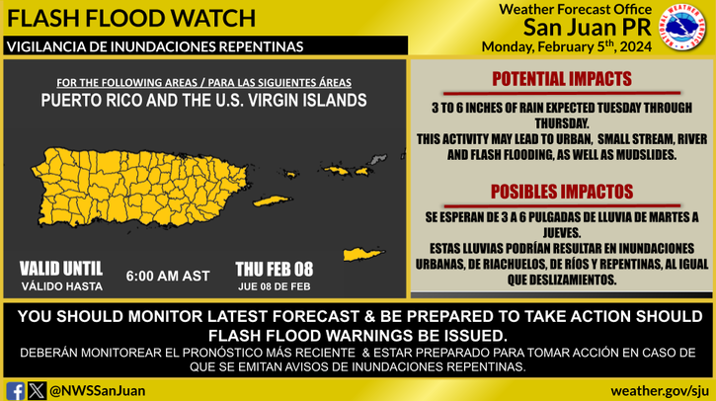

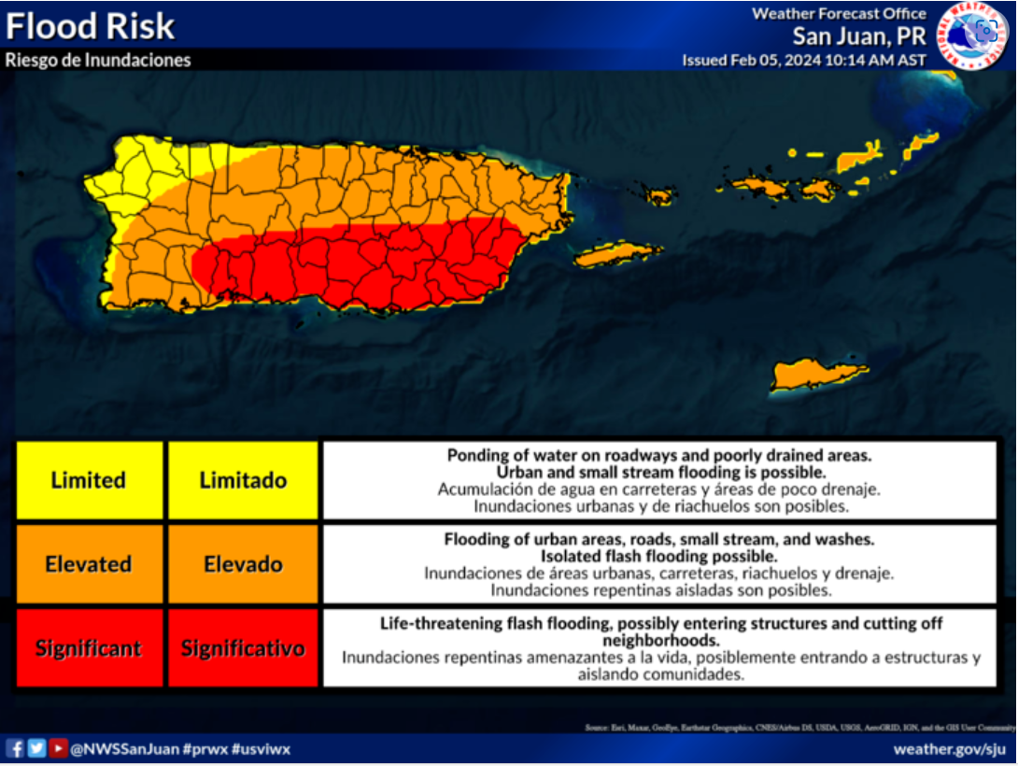

**04/22/2024:**

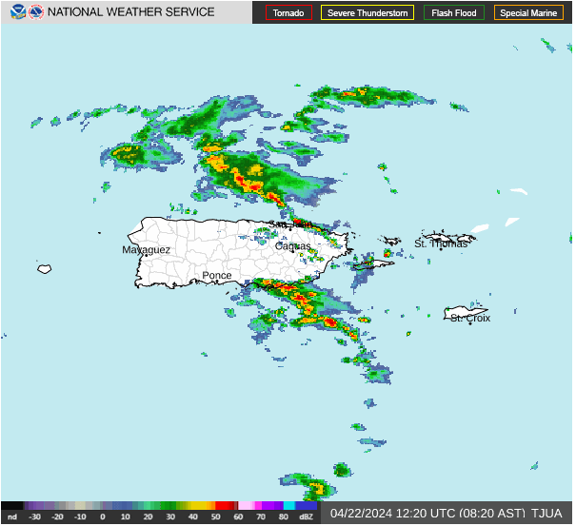

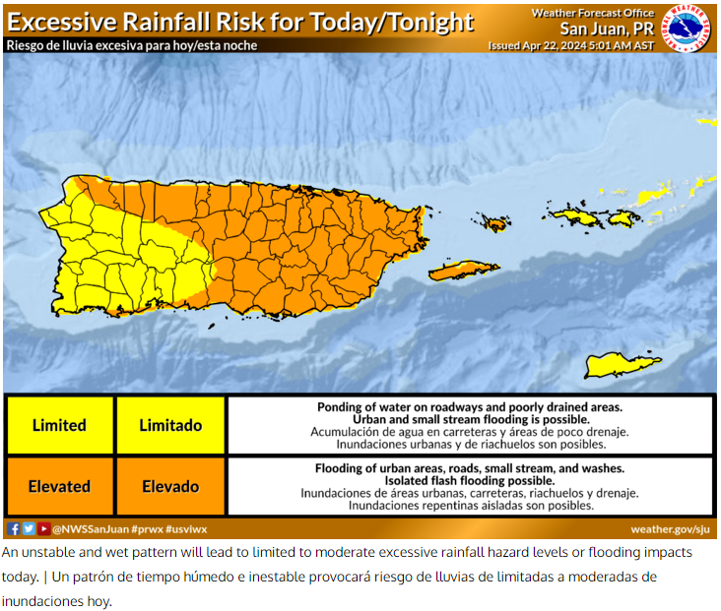

**07/01/2024: Hurricane Beryl**

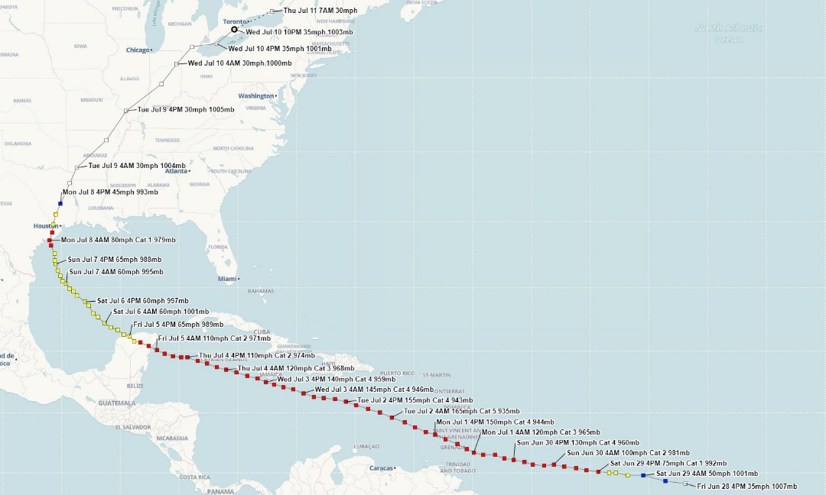

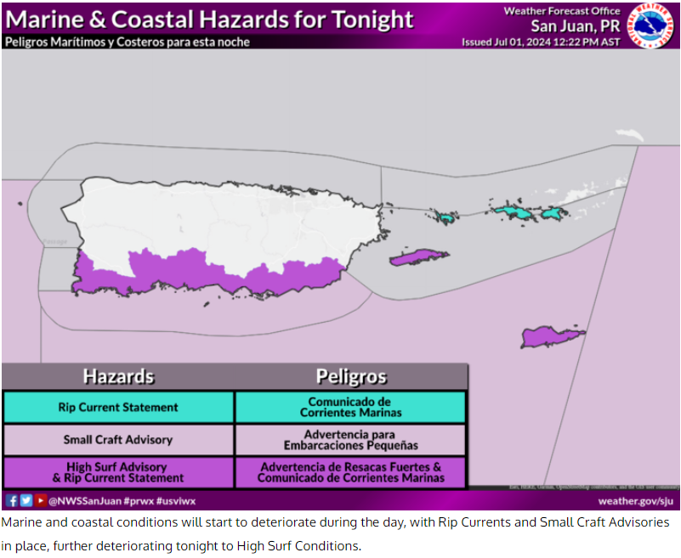

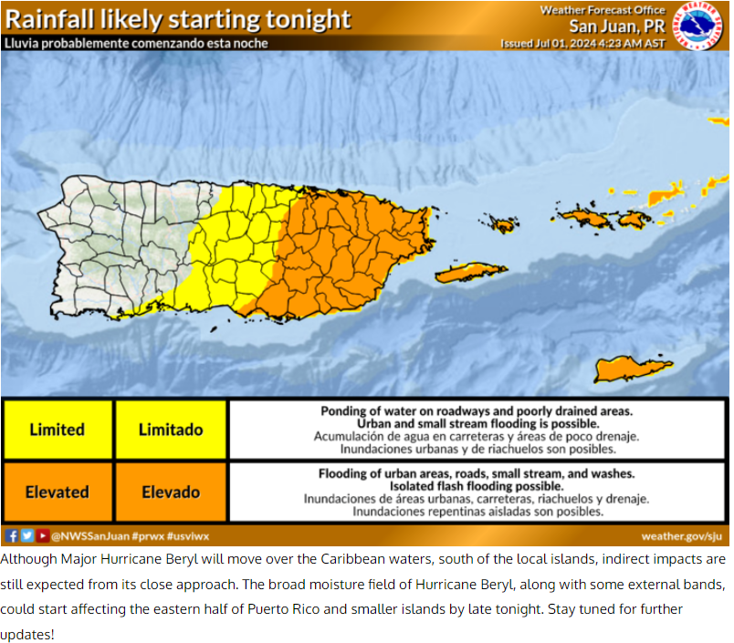

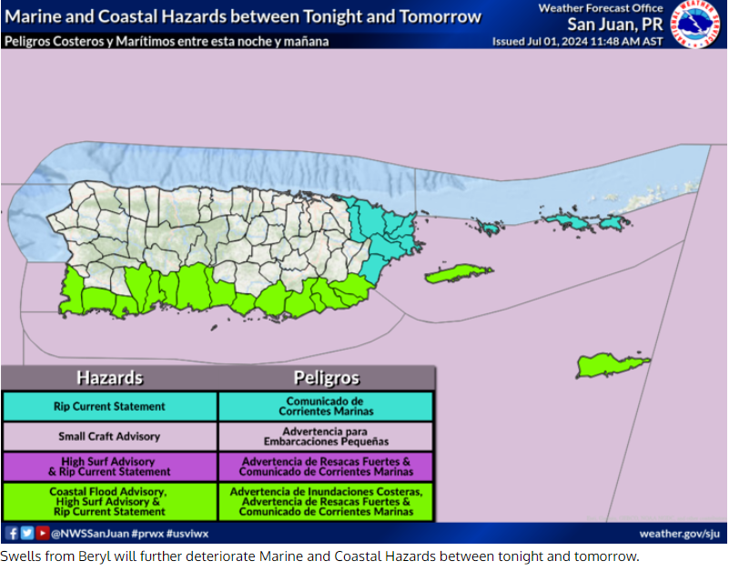

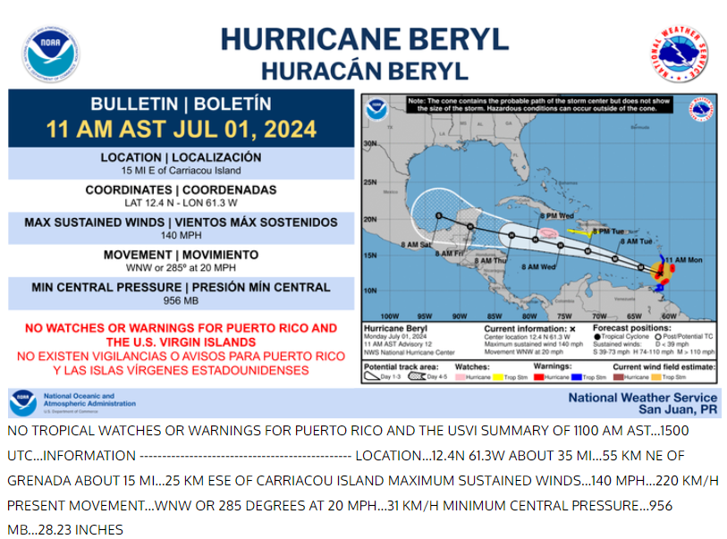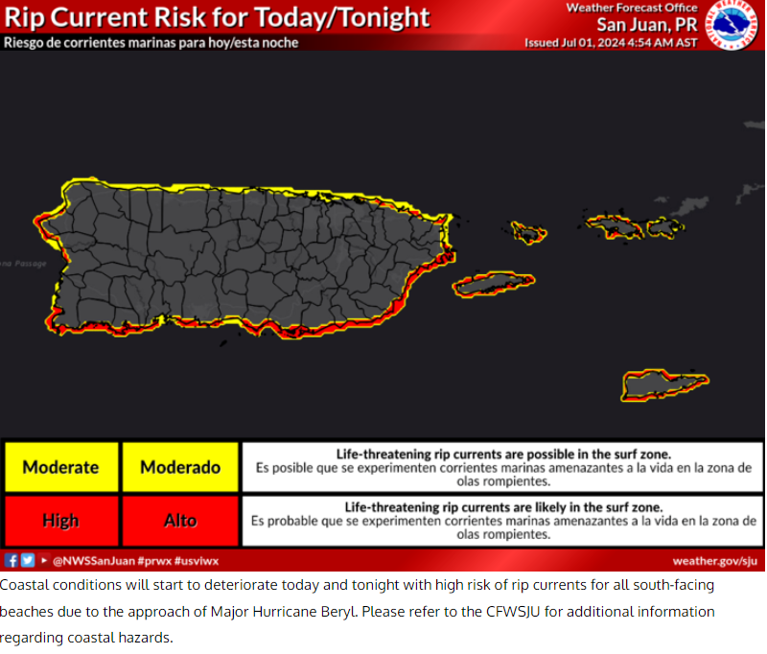

**07/02/2024: Hurricane Beryl**

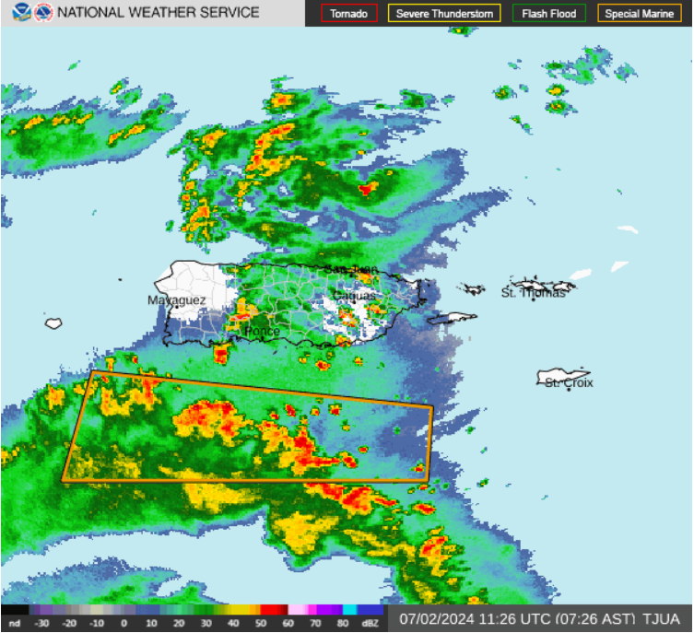

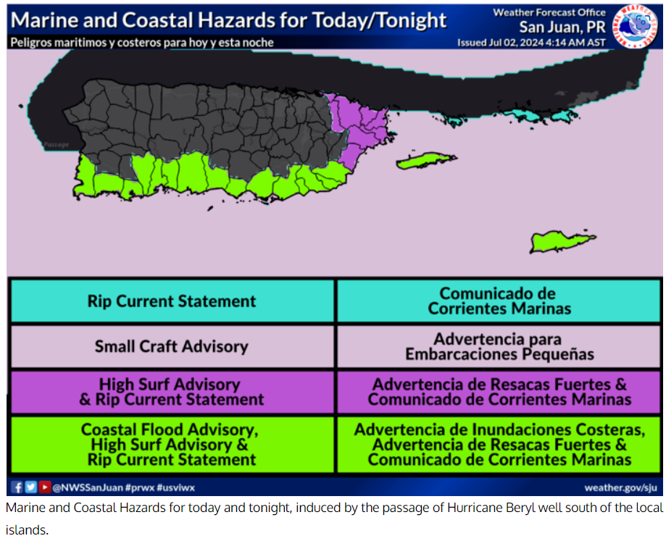

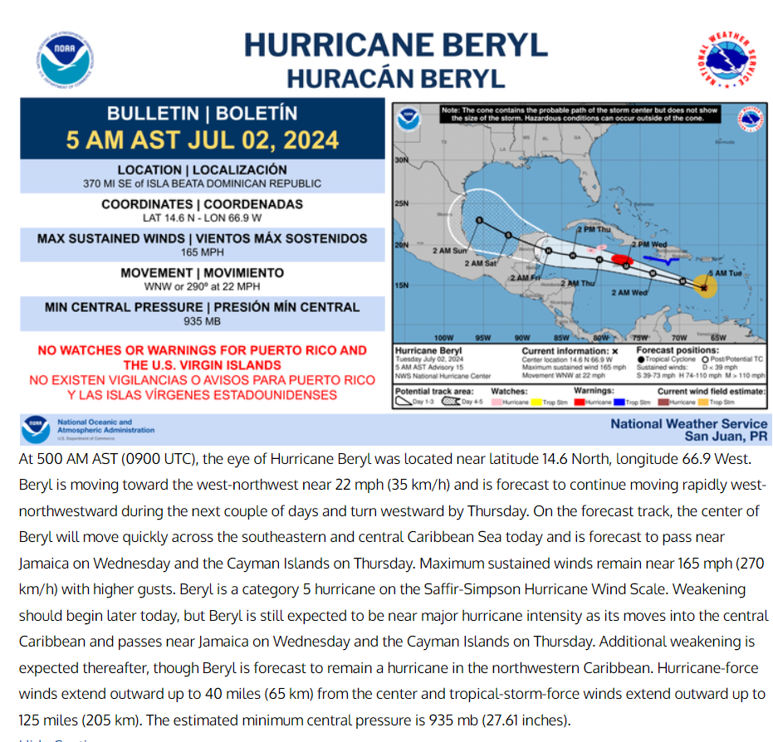

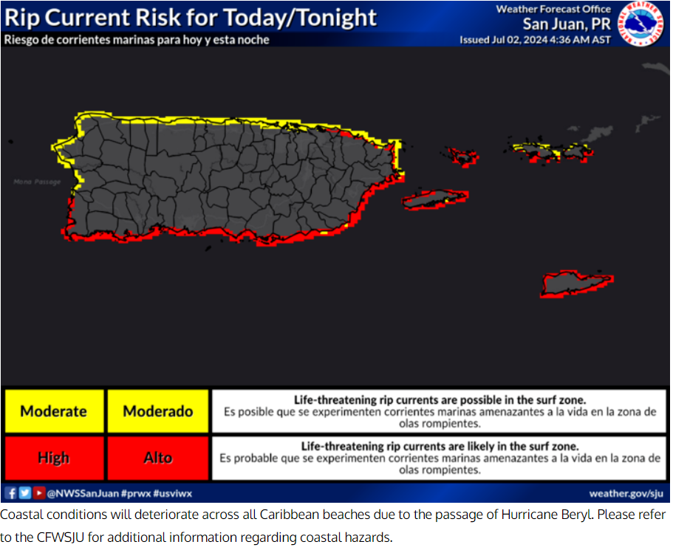

At 11:50 am.

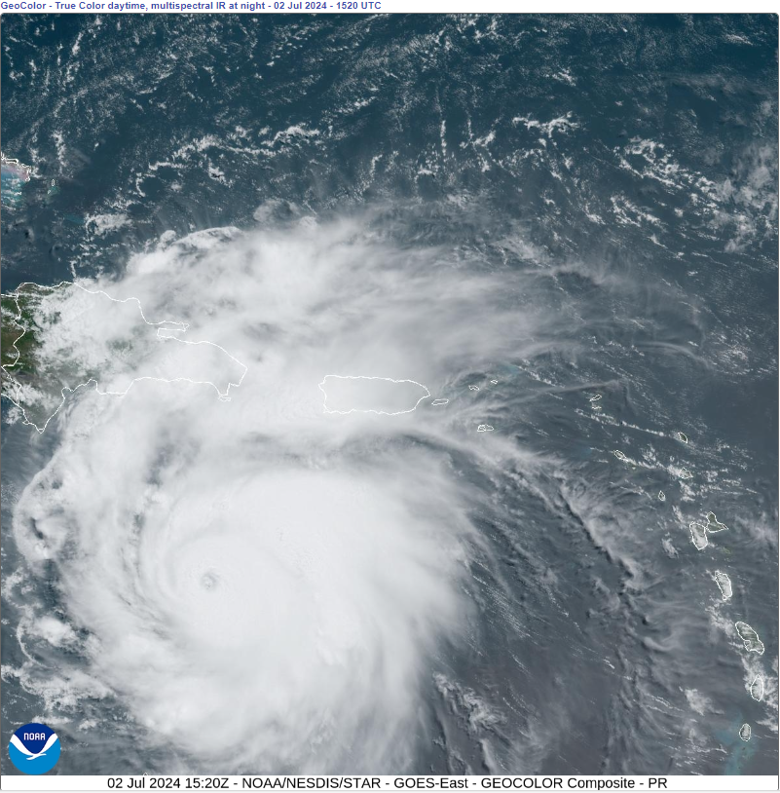

**8-12-2024:**

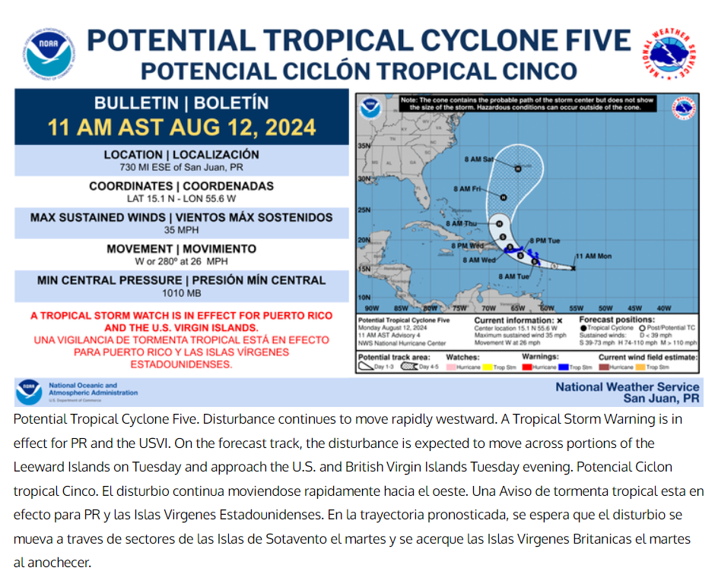

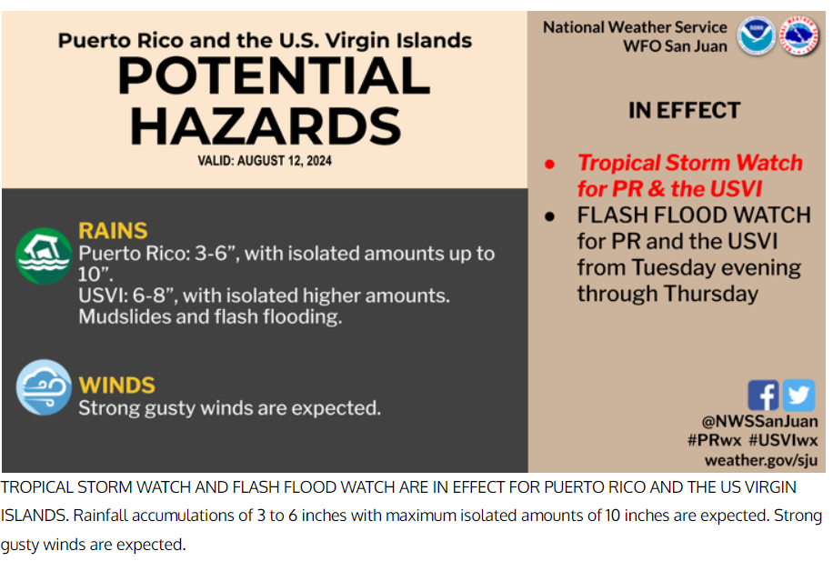

**8-13-2024 to 8-15-2024: Tropical Storm Ernesto:**

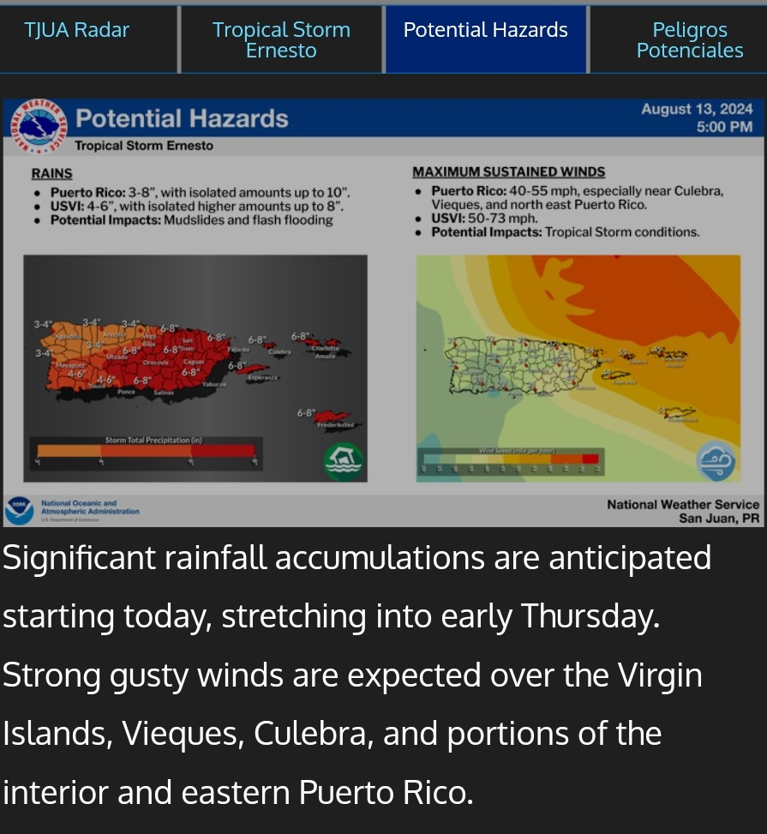

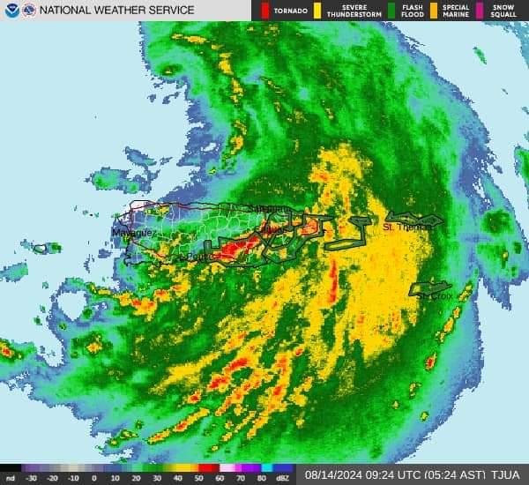

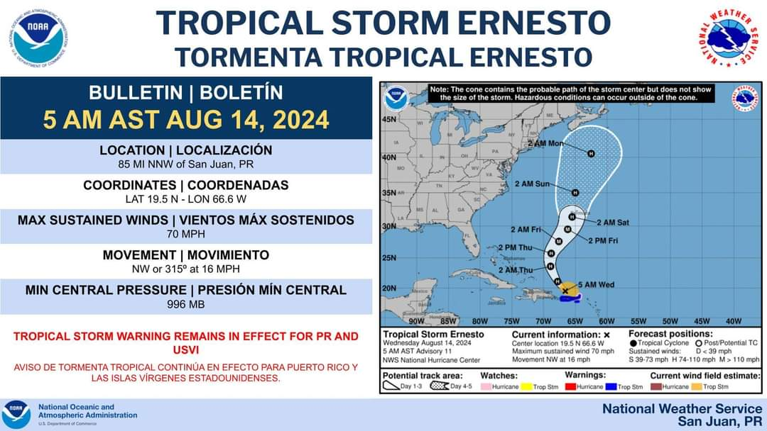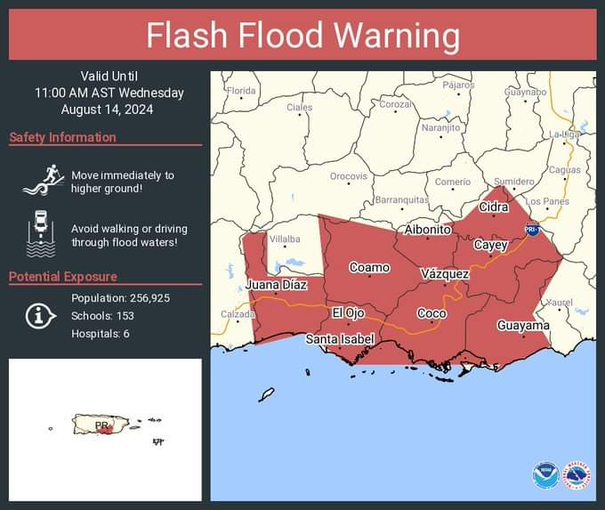

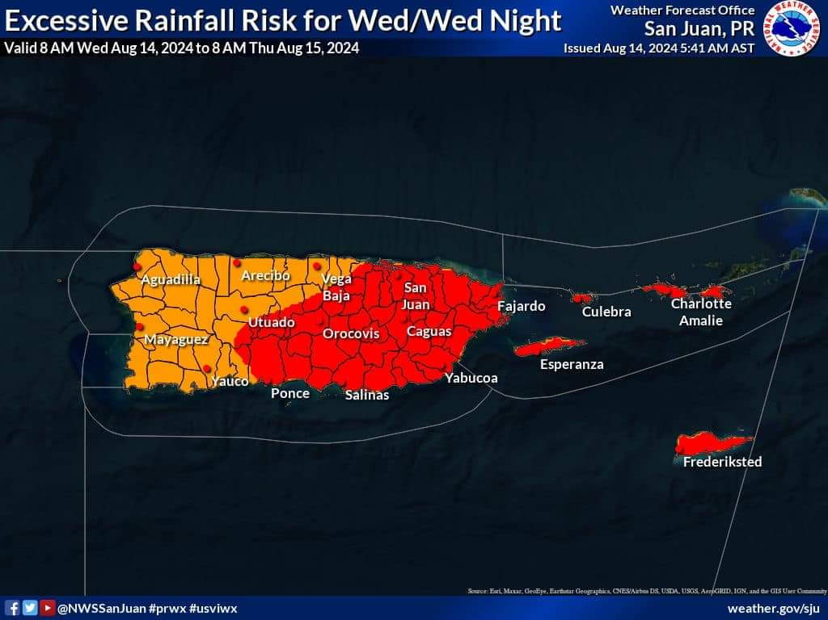

10/4/2024:

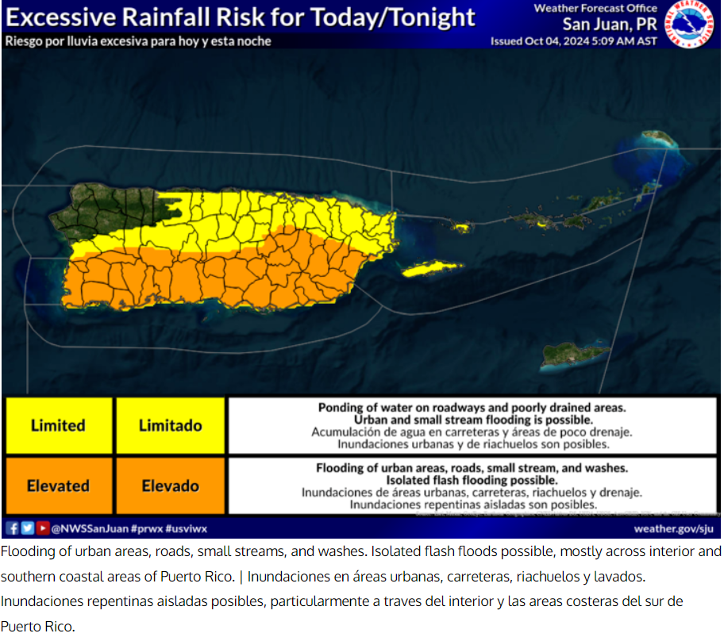

10/31/2024:

